|  |  |
| --- | --- |
| **C:\Users\u100758\Pictures\WI Logo.jpg** | **Do you want to make a difference** **to the NHS**  **in your local area?**  Why?  The NHS impacts on everyone’s lives at one time or another and this could be your chance to get involved in improving, sustaining and protecting the health of the local population.  What’s involved?  NHS Western Isles is looking for two new members to join its Board. These are challenging, rewarding and worthwhile opportunities that will take up around 8 hours a week and last for up to 4 years in the first instance. In return, you will be paid £8,095 a year. You will also get reasonable travel and subsistence costs, dependent carer expenses and support to help you carry out your duties.  Can I apply?  We value very highly the benefits of having different experience and points of view on our Board and we want to hear from a wide range of people who have an interest in public service and are committed to the NHS in Scotland. You do not need to be a health expert or have previous experience of being on a Board. You do need to have a commitment to helping us improve the health and wellbeing of the local population. If this is you, we would like to hear from you. |

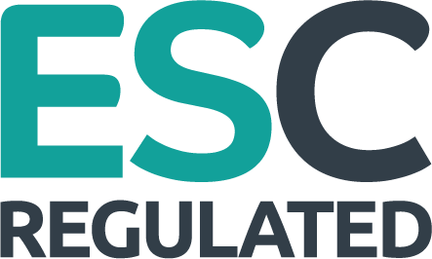

**How do I find out more?**

More information on these roles can be found at the public appointments website: [www.gov.scot/collections/public-appointments](http://www.gov.scot/collections/public-appointments) or by calling

0300 244 1898.

Completed applications must be received on or before

**Wednesday 3rd November 2021.**