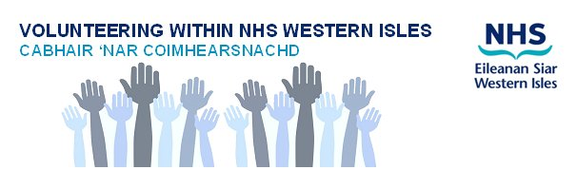

Volunteer Role Description

Role Title: CHSS Hospital Volunteers

Outline of the role: We are looking for ward volunteers who will spend time doing group and 1:1 activities with eligible patients identified by the nurse in charge. Main tasks will be social conversation, activities and signposting to possible community support after discharge.

Skills, Attitudes and Experience needed: The volunteer will have good communication skills and maintain confidentiality at all times. Some knowledge and insight into how medical conditions can affect people would be useful.

NHS Western Isles will provide volunteers with:
- Induction, training and support, e.g. to raise awareness of 'How the organisation works'.
- Explanations of the standards we expect volunteers to adhere to.
- Provide a named person to support. and be available to discuss the volunteer role and any successes or problems.
- A volunteering role that engages your skills, interests and experience.
- Access to information about NHS Western Isles, its history, policies and purpose.
- Out of pocket expenses in line with CEL 23 (2011)
- Insurance
- Subsidised facilities, at staff rates where available;
- Recognition for your service and performance.
- Access to a reference and awards for volunteering i.e. Saltire Award
- A volunteer uniform, identification and access badges where appropriate.
- Opportunity to learn new skills
- Opportunity to meet new people
- Sense of involvement
- Opportunity to make a difference/Help others and enhance their local area

And ensure that Volunteers are:
- Listened to and taken seriously, in the same way as staff
- Able to say no or negotiate tasks and responsibilities
- Able to volunteer in safe premises with safe conditions
- Kept informed about changes within the Board
- Supported in their role

Where: Medical 2, WIH

When: Approx 1-2 hour sessions once or twice per week, as per demand

Support: Lily Mackenzie CHSS Western Isles Co-ordinator. Email lily.mackenzie@chss.org.uk

Any questions: Katherine Stewart, Senior Charge Nurse, Medical 2, WIH Katherine.stewart5@nhs.scot
Interested? For more information about this or any other volunteer role within the NHS Western Isles contact the Volunteer Services Co-ordinator on 01851 704704 ext 2408

