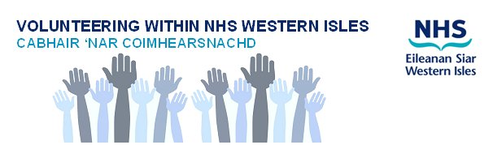

Volunteer Role Description

Role Title: Meet and Greet Volunteer.

Outline of the role: This role is to meet and greet visitors coming into the hospital environment.

- Welcome visitors to the hospital as first point of contact
- Directing patient and visitors to their destination
- Provide a friendly and approachable manner
- To encourage patient and visitors comply with NHS Western Isles safety guidelines while on the premises

Skills, Attitudes and Experience needed:

- Having an interest in people
- Having a friendly and welcoming disposition
- To be flexible for changing demands

NHS Western Isles will provide volunteers with:

- Induction, training and support, e.g. to raise awareness of 'How the organisation works'.
- Explanations of the standards we expect volunteers to adhere to.
- Provide a named person to support. and be available to discuss the volunteer role and any successes or problems.
- A volunteering role that engages your skills, interests and experience.
- Access to information about NHS Western Isles, its history, policies and purpose.
- Out of pocket expenses in line with CEL 23 (2011)
- Insurance
- Subsidised facilities, at staff rates where available;
- Recognition for your service and performance.
- Access to a reference and awards for volunteering i.e. Saltire Award
- A volunteer uniform, identification and access badges where appropriate.
- Opportunity to learn new skills
- Opportunity to meet new people
- Sense of involvement
- Opportunity to make a difference/Help others and enhance their local area

And ensure that Volunteers are:

- Listened to and taken seriously, in the same way as staff
- Able to say no or negotiate tasks and responsibilities
- Able to volunteer in safe premises with safe conditions
- Kept informed about changes within the Board
- Supported in their role

Where: Western Isles Hospital

When: Meeting and Greeting Volunteering will be on a flexible basis and will be arranged by negiotation and agreement.

Support: The point of contact will be the Patient Services Manager who will offer support if you have any concerns.

Any questions: Please contact Chris Ann Munro, Patient Services Manager on email at christina.munro@nhs.scot or by telephone on 01851 704704 ext 2241

Interested? For more information about this or any other volunteer role within the NHS Western Isles contact the Volunteer Services Co-ordinator on 01851 704704 ext 2408

