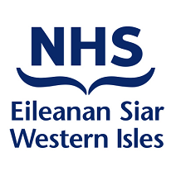
Spiritual Care, Diversity & Bereavement Support Department

Bi-annual Equality & Diversity Mainstreaming Progress Report 2021-22

Equality Act Statutory Report 2023

Authors
Mr Murdo Macleod Operational Diversity Lead

April 2023

Executive Summary

NHS Western Isles has a duty under the Public Sector General Duty, Equality Act 2010 and (Specific Duties) (Scotland) Regulations 2012 to work towards meeting the following aims:

- Eliminate discrimination, harassment, victimisation and any other conduct that is prohibited under this Act
- Advance equality of opportunity between persons who share a relevant characteristic and persons who do not, and
- Foster good relations between people who share a protected characteristic and those who do not.

This report provides evidence against these requirements. It also provides assurance to the public that the organisation is making progress to address any issue that affects mainstreaming of equality in its operations.

The severe impact of the COVID-19 pandemic on NHSWI service capacity and delivery has led to constraints on the width of data and content that was solicited and collated for this Report in the period from Autumn 2020 to the time of publication, in comparison with previous years. These COVID reporting repercussions are not unique to NHSWI, given that they are felt not just by the other NHS Scotland Boards but by all public bodies in Scotland.

Content of the Report

The report will give:
Assurance to the board of NHS Western Isles that the organization is making progress to address any issue that prevents mainstreaming of equality in its operations.

An account of steps the organization has made to mainstream equality and the impact of these ventures.

The Equality Outcomes will relate directly to the 2010 Equality Act Protected Characteristics, and the updates given pertain both to the welfare of patients and staff.

The report will be published on the NHS Western Isles public website and will be available to Equality Focus Groups locally and nationally, as well as our submission of evidence to the Equality & Human Rights Commission.
Contents

- INTRODUCTION

- MISSION STATEMENT

- MAINSTREAMING IN STRATEGIC ASPIRATIONS

- MAINSTREAMING ACROSS THE FUNCTIONS AND PURPOSES OF THE SERVICE

- Appendices

NHS WESTERN ISLES
DEPARTMENT OF SPIRITUAL CARE, DIVERSITY & BEREAVEMENT SUPPORT
MAINSTREAMING REPORT FOR 2010 EQUALITY DUTY

APRIL 2023
- Introduction

NHS Western Isles serves a population of 27,684 (2011 census initial estimate) residents over 8 populated islands, and works in partnership to provide Health and Social Care services to this population.

NHS Western Isles employs 1054 people in its operations (as of March 2022), a Whole Time Equivalent of 526 posts. It is therefore a hugely significant employer in the community, making a major contribution to the economy of the islands.

In addition to the Equality Act General Duty contained in the Executive Summary, we are required by the end of April 2023 to discharge the following Equality Act Specific Duties for Scotland: -

- Report progress on mainstreaming the public sector equality duty every two years.
- Publish equality outcomes and report progress.
- Assess and review policies and practices (impact assessment) on an ongoing basis.
- Gather, use and publish workforce Equality and Diversity information in the mainstreaming report.
- Publish statements on equal pay.
- Publish gender pay gap information.
- Publish in a manner that is accessible.

This report, which is a bi-annual one, is a submission by NHS Western Isles to the Equality and Human Rights Commission Scotland, to demonstrate how we are meeting the requirements of the 2010 Equality Act. Equality Duty requirements are integral to the exercise of our functions. The following report covers progress on adherence on the part of NHS Western Isles as a Public Authority to the protected characteristics of the 2010 Equality Act.

Benefits to health boards in mainstreaming Equality and Diversity can be listed thus:

- Equality is embedded in the systems, functions, and culture of the board.
- Policy making is improved by avoiding the development of policies and programmes that inadvertently sustain or compound existing inequalities.
- Enhanced performance of core health practice and improved outcomes for patients and service users
- Improved quality of service design and delivery, i.e., equitable access and equity of informed, person-centred care
- Established transparency in relation to board functions such as procurement and workforce recruitment, development, and equal pay.
- Workforce is trained, supported, and equipped to deliver an equitable and person-centred informed health care response.
- Capacity maximised through collaborating with partner agencies and Community Planning Partnerships (CPPs)

- Maximised participation in decision-making by local people with protected equality characteristics and those with experience of social inequalities
- Able to demonstrate compliance with equality legislation to the Scottish Equality and Human Rights Commission

There is also a strong business case for Equality and Diversity. A substantial body of evidence shows that managing diversity is key to:

- an organisation’s reputation - a good reputation attracts talent from all communities, helping to meet service delivery needs.

- staff recruitment and retention - valuing diversity enables employers to recruit and retain the best people for the job.

- productivity - staff perform better in organisations that value diversity and are committed to employees' well-being.

- mitigating organisational risks - effective diversity management limits the risk of legal challenges and costly awards.

- NHS Western Isles Mission Statement

“To be the best at what we do”

The above mission statement applies not only to our clinical practice, but also how we treat our service users and our staff with equity.

Alongside the above statement, NHS Western Isles will aim to provide a dignified, safe and equal service provision for all its service users.

- MAINSTREAMING IN STRATEGIC ASPIRATIONS

3.1 Embedding in NHS WI Corporate Plan

NHS Western Isles’s commitment to fairness and diversity for all who come into contact with its services is made in a very transparent way in the organisations’s Corporate Values and Objectives 2017-20. Three of the Corporate Values state, as follows:-

Dignity
We will respect and value the right of the individual to be the person they are.

Fairness
We will make judgements that are based on merit and free from discrimination, dishonesty and injustice.

Reinforcing this, in the list of Corporate Objectives:

- CO1 -To provide person-centred care, focusing on the evidence-based health needs of our population, identifying and taking every opportunity to improve our patients health and experience.
- CO5 - To specifically target early years, health inequalities, vulnerable and hard to reach groups.
3.2 NHS WI Equality and Human Rights Policy

NHS Western Isles’s Equality and Human Rights Policy was completely refurbished and approved in 2016 to take account of national policy drivers and strategies in the field that had emerged since the first iteration of the Policy. Some of these drivers will be highlighted within this Report.
It was organised as well in a more concise and concentrated form, to improve engagement with it on a meaningful basis. It is embedded here:

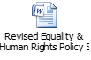

  - NHS Scotland Quality Strategy

The developments outlined herein across NHS Western Isles services and functions are compliant with the elements of the NHS Scotland Quality Strategy and the 2020 Vision for Health and Social Care in Scotland. The Quality Strategy has three Quality Ambitions – Safe, Person-Centred and Effective.
As Scotland recovered from the pandemic, Healthcare Improvement Scotland set out a Plan at the end of 2021 to improve health outcomes for people and to tackle deep-rooted inequalities. The actions are firmly informed by the foundation of Scotland’s Healthcare Quality Strategy. It is envisaged that this Strategy for 2022-27 will be a sturdy framework for meeting the challenges of the years ahead.
It is embedded here:-

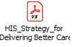

3.4 NHS Scotland Charter of Patient Rights and Responsibilities

This Charter, published for the first time in 2016, influenced as it was by the launch of Scotland’s National Action Plan for Human Rights in 2014, was fully revised in June 2019. The Charter enshrines the principle of mutual respect – that is, everyone who uses and provides NHS services has a right to be treated as an individual and with consideration, dignity and respect.
The 2019 revision for the first time incorporates a commitment to uphold the right to the provision of communication equipment and support and the right to access interpreter services. This is an explicit commitment of Part 4 of the Health (Tobacco, Nicotine etc.and Care) (Scotland) Act 2016, which placed a legal duty on NHS Boards for the first time to provide or secure communication equipment. This is a welcome acknowledgement of those with Assisted and Augmentative Communication needs.
Patients in the Western Isles with conditions such as Parkinsons, suffering from the effects of a stroke or with a cognitive impairment are therefore benefiting from better recognition of the vital nature of thereapeutic communication aids such as Talking Mats, Makaton or the groundbreaking Gaelic Speech Therapy and Gaelic (STaG) resource. The multi-agency Western Isles Assisted and Augmentative Communication Pathway is proving a coherent framework for mobilising support to where there is need.
The Easy Read version of the Charter is embedded here:

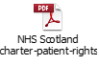

3.5 Scottish Government’s National Islands Plan 2019 and Island Communities Impact Assessment 2020

A major national contribution towards achieving parity between the major urban conurbations in the Central Belt and remote and rural areas such as the Outer Hebrides has been the launch of the Scottish Government’s National Islands Plan at the end of 2019. The Plan, built on the foundation of the Islands (Scotland) Act 2018 and assembled with the input of many islanders, provides a framework for action with 13 Strategic Objectives to mobilise outcomes for island communities such as ours.
This was followed in 2020 by the Island Communities Impact Assessment from the Scottish Government. This is an evaluation process for Local Authorities in Scotland to improve outcomes for island communities. When a new strategy, policy or service is being developed the Local Authority uses the framework of the Impact Assessment to examine how the proposal will affect island communities. If there are negative impacts ways of mitigating these can then be agreed on. Both are embedded here:

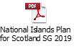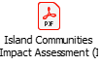
However, it could be said that there is as great a need, if not greater, for the Scottish Government to apply this srutiny on their own national policies that emanate from the centre to cover all Scotland. The consequences of these on the fragile infrastructure of Scotland’s islands are not always thought through. Examples of these recently have been the detrimental impact of the job losses sustained to Tighean Innse Gall because of the new home ventilation regulations being wholly unsuitable for the climate of the archipelago and the proposal – now dropped – to centralise air traffic control at Highlands and Islands Airports, which would have seen the closure of Stornoway Air Traffic Control.

3.6 Diversity and Equality co-operation

The Western Isles Diversity and Equality Steering Group has not convened physically since the onset of the COVID-19 pandemic. However, since 2020 the NHSWI Equality and Diversity Team continues to share key developments and resources remotely with inter-agency colleagues for mutual benefit. On a Scotland-wide basis, the Team are members of the Scotland NHS Equality Leads Network. Prior to the pandemic the Network met three times a year, but now convenes once a month remotely on Microsoft Teams. This has improved the mutual support and policy influencing that is integral to the work of the Network.
This collaborative approach is echoed in NHSWI’s aspirations for public engagement and dialogue re: the effectiveness of its services. The work together of the Equality and Diversity Team, the Patient Focus Public Involvement Officer and the Scottish Health Council seek to embody the Scotland National Standards for Community Engagement, as seen in the infographic below. The Standards were wholly refreshed & revised in the light of the Community Empowerment (Scotland) Act 2015. The publication of the National Islands Plan as already highlighted has consolidated the impetus of the Standards in safeguarding civic life in fragile remote communities such as our own.

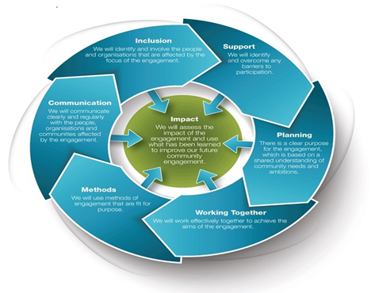

3.7 Fairness Assessment Tool

It is now incumbent on public bodies to impact assess all new and reviewed policies, protocols and strategies for compliance with the Equality Act 2010 Public Sector General Duty, Equality Act 2010 and (Specific Duties) (Scotland) Regulations 2012 This is to ensure that any new policies are inclusive, and not discriminating against any group. A large number of Indirect Discrimination breaches occur because of the unforeseen impact of a new directive on one group, so, in seeking to minimise the risk of this happening, the importance of equality impact assessment is crucial.

NHS Western Isles is now using a revamped equality impact assessment formula, the Fairness Assessment. This format examines any potential impact of a policy, protocol or strategy on the 2010 Act Protected Characteristics and the European Convention of Human Rights requirements. Policies and procedures that potentially impinge on the whole population are being planned around the Fairness Assessment outreach approach. The Fairness Assessment can be viewed in Section 5, Appendix 2.

3.8 Deprivation

Research in Scotland has shown how crucial the social determinants of health are, and how penetrating their legacy is throughout the lifespan ( The Economic and Social Research Council 2014, University of Stirling 2013, Scottish Government Communities Analytical Services 2010, Scottish Government 2009 and 2008). The recently published Health Inequalities in Scotland: A GP View cited that patients from deprived areas had more multimorbidity, more psychological problems, more chronic health problems and reported not having enough time to discuss these with their GP. Yet they had shorter consultations, had to wait longer for an appointment, GP stress was higher and patient empowerment lower. Scottish Government figures show that one in four children in Scotland are living in poverty, 68% of children living in poverty are in households where someone works, 38% of children in lone parent households live in poverty and 29% of children with a disabled family member are in poverty.
The Poverty in Scotland 2021 Report by the Joseph Rowntree Foundation stipulated that the voices of people experiencing poverty are clear and need to be heard, and highlighted that social security is not protecting people from poverty when it should. It made recommendations to both the Scottish and UK Governmnents.
It is embedded here:-

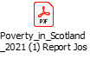

A recent major national policy driver here has been The Fairer Scotland Duty, Part 1 of the Equality Act 2010, which came into force in Scotland from April 2018. This places a legal responsibility on particularly public bodies to actively consider (pay due regard to) how they reduce inequalities of outcome caused by socio-economic disadvantage, when making strategic decisions. The rationale behind this new Duty can be seen in the diagram on the next page.

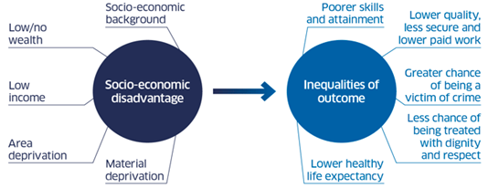

Also in relation to national policy, following on from the first Tackling Child Poverty Delivery Plan, ‘Every Child, Every Chance’ the Scottish Government published its second Tackling Child Poverty Delivery Plan 2022-26, ‘Best Start, Bright Futures’ in March 2022. It outlines a range of measures and actions with partners to provide the support families need immediately and in the medium to longer term. It is embedded here:

NHS Western Isles recognises the importance to health improvement that tackling deprivation will make to the health of the population of the Western Isles. The Health Promotion Department has been engaging with others to build a consensus of concern around the issue.

Since the creation of the multi-agency The Western Isles Poverty Action Group in 2012 from this concern, they have continued to do sterling work. These take on board not just the the concerns intrinsic to the Fairer Scotland Duty but the responsibilities emanating from The Child Poverty (Scotland) Act 2017. This Act works to set targets relating to the eradication of child poverty. It sets a duty requiring local authorities and territorial NHS Boards to publish an annual report on activity to tackle child poverty.
Thinking of our location, it has been estimated that rural poverty accounts for 16% of all poverty in Scotland, affecting approximately 160,00 people. Our island communities are beautiful yes, but the pushing up of house prices beyond the reach of locals to suit second home owners causes what is called spatial apartheid, making them far from a rural idyll for many. Fragile, short term employment and the necessity of car ownership with its corresponding impact on household expenditure are other distinctive characteristics of rural poverty.

The inaugural Outer Hebrides Anti-Poverty Strategy 2019-24, which contains the Local Child Poverty Action Report 2019 – 24 & published jointly by the local authority, the Outer Hebrides Community Planning Partnership and NHS Eileanan Siar, enshrines for the first time therefore the concerted response to the challenge illuminated by the Child Poverty (Scotland) Act.
It is embedded here:-

The contributions of NHS Eilean Siar staff in Maternity Services, Health Visiting & Health Promotion are pivotal to the actions listed on Appendix 2 of the Strategy.

Demand on the Stornoway foodbank quadrupled over 2022 in comparison with 2019/20. Health Promotion have identified as a concern the cultural reticence among our elderly citizens which makes them relucant to disclose problems around poverty, including heating struggles. As many have a strong church affiliation, congregational pastoral visiting schemes could be a very effective way of identifying these difficulties, taking the burden off the individual to disclose, and subsequently connecting them to the appropriate supports.
A Health Promotion Practitioner organised a food distribution scheme in the Ceàrns in 2021. The disused polytunnel was revitalised, which led to the renewal of the horticultural project in the Ceàrns. This subsequently informed a successful funding for and purchase of two Polycrubs. Residents began to grow their own vegetables. Funding was also received for a number of bicycles to faciltate exercise.
This helped to mitigate the impact on those people who were furloughed because of the pandemic. Some of these were unable to return to gainful employment. These people adversely affected by furlough were directed to Western Isles Citizens Advice Bureau and the Local Authority’s Financial Inclusion Centre, as well as to the local Foodbank.
Over 50 people were interviewed for the Get Ahead Scotland initiative, linked to the Poverty Alliance. These raised very valuable issues which were fed back to the Poverty Alliance. As a consequence it is intended to start a Get Ahead Hebrides group as a response. It is hoped that this will really give the disenfranchised and marginalised amongst us a voice. This will inform the WI Child Poverty Action response.

3.9 Inclusion and Empowerment

Virtual Visiting
Conscious of the emotional and mental health impact on patients on not being able to see their family members when hospital visitation was severely restricted at the height of the COVID-19 pandemic, in 2021 NHSWI launched a Virtual Visiting service. This imaginative solution around the issue of patient isolation made a real difference to patient wellbeing and family reassurance at such a worrying time for everyone.
The kind donation of 20 iPads from Health Improvement Scotland meant that patients without smartphones – particulary true in relation to elderly patients – could see their loved ones for a conversation that adhered to Infection Control precautions and regulations. Liaising with the Virtual Visiting Co-ordinator, the family members would be given a suitable time to link in with the Virtual Visiting remote platform. With the support of the Ward Clerks an iPad is delivered to the patient, at which point both they and their family member begin their conversation via the platform.
The feedback for the scheme has been enormously positive.

iESO Remote Cognitive Behavioural Therapy Service
, NHS Western Isles has successfully developed a pilot CBT (Cognitive Behaviour Therapy) partnership in conjunction with IESO Digital Health.
Originally supported by the Western Isles Integrated Joint Board (IJB), in 2017 the NHS Western Isles Psychology Service initiated the pilot project with iESO Digital Health to bring remote CBT delivered virtually (by live messaging writing to and fro to a qualified therapist on computer or phone) to those living across the Outer Hebrides. Given the small scale of the local psychology service in relation to its mainland counterparts, it was hoped the pilot project would increase capacity locally for IESO Digital Health’s Cognitive Behaviour Therapy (CBT). This would result in saving patients the time, inconvenience and expense incurred in travelling to appointments. This has proved considerable success. Since May 2019 almost 400 adults of all ages across the Outer Hebrides now refer themselves for virtual CBT help each year via the iESO platform. In addition, of those who chose the virtual route, 64% stated they preferred the option of out-of-hours appointments. A performance review in 2021 indicated that patient experience ratings had all been positive against various headings, and that patients who reported an improvement in their mental health are comparable to other services for which there is regular CBT provision.
Western Isles Patient Panel
The Western Isles Patient Panel was established in 2019 to enable people with lived experience to inform practice development and quality improvement. The Panel brings together representatives of existing Patient Peer Support Groups and Managed Clinical Networks, with a strengthened focus on disability and human rights. It also includes third sector partners supporting mental health, carers, advocacy, chest, heart and stroke conditions, and people living with dementia. The Panel covers all geographic communities across the Western Isles.
Since the pandemic the Panel is now meeting virtually. Healthcare services in the Western Isles had to change very quickly in order to respond to the COVID-19 pandemic, including the increased use of technology and prioritisation of key services.
NHS Western Isles sought the views of the Patients Panel to support the planning of services remobilisation on emerging out of the pandemic. A survey was distributed via the Patient Panel to their respective Patient Peer Support Group members and to third sector organisations that had access to communities of interest, such as people living with dementia, learning disability or mental health conditions. The purpose was to assess how people living with long term conditions and who were shielding had been impacted by the pandemic, and to capture their experience of accessing health care during this time.

Before the pandemic:
- The Patient Panel originally covered Lewis and Harris and Barra. Uist opted out as they felt their current engagement mechanisms met their needs.
- Meetings were held separately in each geographic area, quarterly in Lewis and Harris and 6-monthly in Barra.
- There were around 9 members participating in any Panel at any one time, covering issues such as mental health, continence care, disabled access and carers' issues.
- Engagement was community-based, within each island.
As a result of the pandemic:
- MS Teams allows a meeting to be organised covering the whole health board area, with the geographic communities all being represented to share their unique experience. This received positive feedback with a lot of shared learning.
- Panel members asked NHS Western Isles to increase the frequency of meetings from quarterly to monthly or 6-weekly, in the short term.
- The Patient Panel has grown and now covers the whole of the Western Isles. Patients and carers can join meetings to discuss matters of interest and issues across all geographic communities.
- Third Sector organisations on the Panel represent communities of interest, including mental health, carers, advocacy, chest heart and stroke and people with dementia.
- Approximately 31 members are now linking in via MS Teams.
- There is shared learning across the island chain and improved communication between patient groups and organisations.
- Disability Access Groups have told us that technology has levelled the field in terms of engagement as they could potentially feel left out in terms of ability to access meetings due the remote nature of our environment.
- Over 20 requests have been received from communities and individuals for help on how to engage with health and care services.

MAINSTREAMING ACROSS THE FUNCTIONS AND PURPOSES OF THE SERVICE

Expanding on this preamble, progress thus far in instilling the Equality Duty into the heart of our functions and services will be here outlined. These will be listed centred on the Protected Characteristics, with reference both to Patients and Public, and staff.

The infographic on the next page shows all the Equality Act Protected Characteristics & the values instilling them.

2010 EQUALITY ACT PROTECTED CHARACTERISTICS

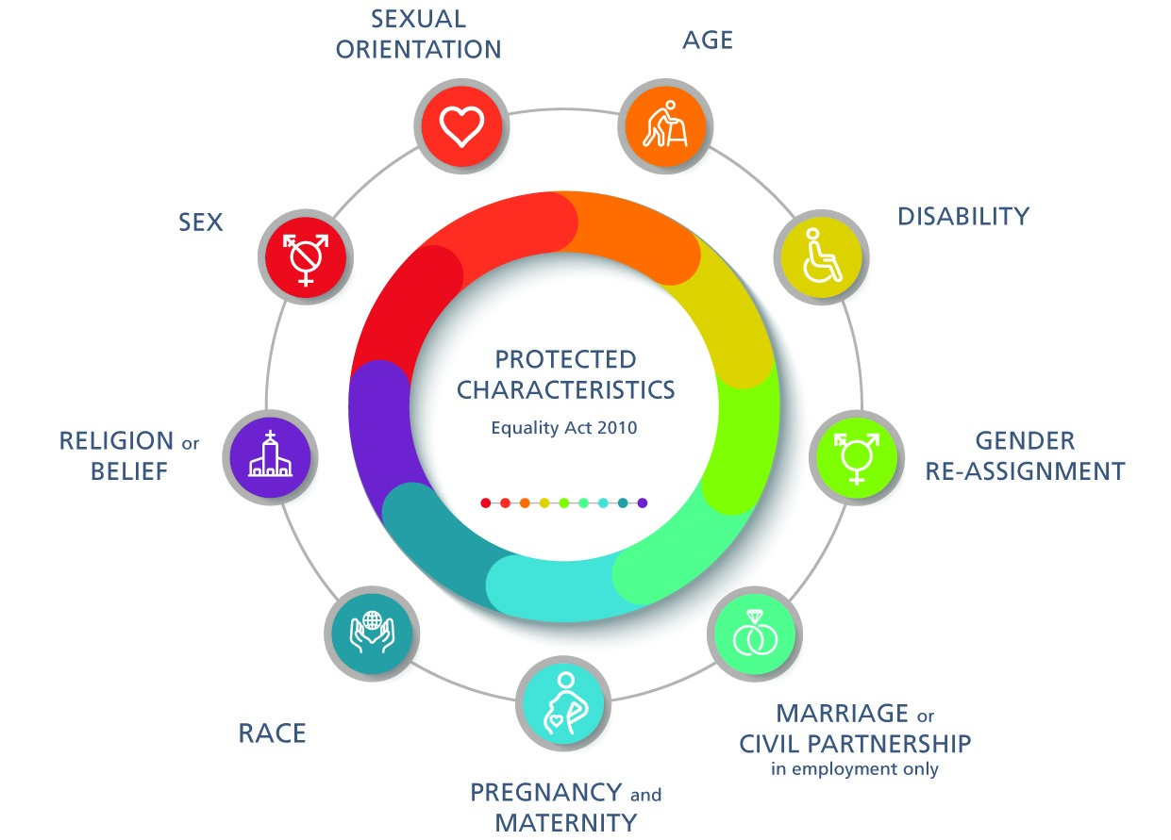

OUR RIGHTS FOR OURSELVES, OUR RESPONSIBILITIES
TO OTHERS

4.1 RACE

Outcome
Patients from all backgrounds and ethnicities to be free from discrimination & harassment, with the safeguard of redress being open to all.
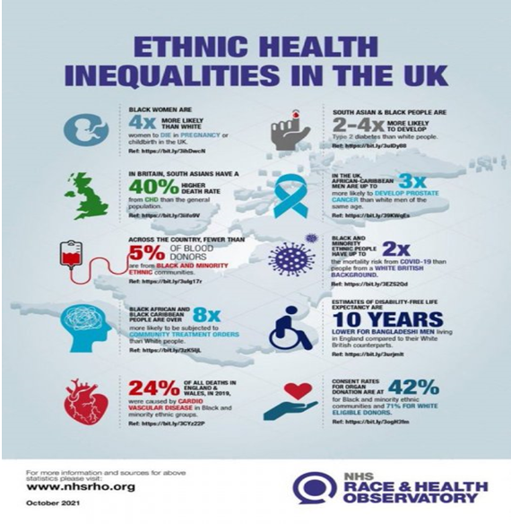

Rationale
In the UK as a whole, ethnic differences are most marked in the areas of mental wellbeing, cancer, heart disease, HIV, TB and diabetes. BME populations may face discrimination and harassment and may be possible targets for hate crime.
In the Western Isles, the 2011 Census showed that the percentage of people born outside the UK in the Outer Hebrides had increased from 2 per cent in 2001 to 2.9 per cent in 2011. This comprised of 1.1 per cent who were born within the EU & 1.7 per cent who were born in other countries excluding Northern Ireland and the Republic of Ireland. The Census also showed that Polish people in Scotland had the lowest level of English language skills of all the ethnic groups.

A recent major policy driver here has been the Race Equality Framework for Scotland 2016-30, followed by the Fairer Scotland For All Race Equality Action Plan 2017-21. The Action Plan is pivotal for advancing race equality, tackling racism and addressing the barriers that prevent people from minority ethnic communities from realising their potential.

As we emerge from the shadow of the COVID-19 pandemic, for many people from minority ethnic communities in Scotland, the pandemic has exposed, or worsened, existing inequalities in society. Across the UK people from Afro-Caribbean and Pakistani/Bangladeshi ethnic groups had significantly worse outcomes in susceptibility to the virus and in-patient hospital treatment, as well as lower uptake rates of the vaccines that emerged at the end of 2020. The Expert Reference Group on Covid-19 and Ethnicity that was set up in 2020 provided the Scottish Government with the evidence and considered challenge needed therefore to ensure greater equity for minority ethnic Scots. Subsequently the Scottish Government published the Immediate Priorities Plan for Race Equality in Scotland as a response in September 2021. This Plan includes recovery from the pandemic as well as areas as diverse as wider health priorities, education, housing, fair work, poverty and social security. It is intended to afford a route map for the way ahead to 2023.
Also In October 2021 the Scottish Government published its Consultation on Scotland Becoming A Fair Work Nation. Building on what had already been done to ensure people from a minority ethnic background can access, stay and progress in employment, such as the Public Sector Leadership Summit on Race Equality in Employment, race was highlighted along with disability and mental health and injury within a Fair Work Convention Measurement Framework.
Both of these documents are embedded here:-

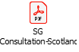

The charts and tables below show firstly the COVID-19 hospitalisation/death outcome and positive cases by ethnic grouping in Scotland, followed by the Western Isles COVID Vaccine uptake by ethnic group for Doses 1 and 2. In interpretation of the second bundle, it should be recognised that there are much smaller numbers of minority ethnic groupings in the Western Isles than in the Central Belt urban centres, so not too much should be read into the representation here. Interestingly there was a significant increase in Bangladeshi uptake of the second vaccine locally in comparison with the first one, as can be seen.
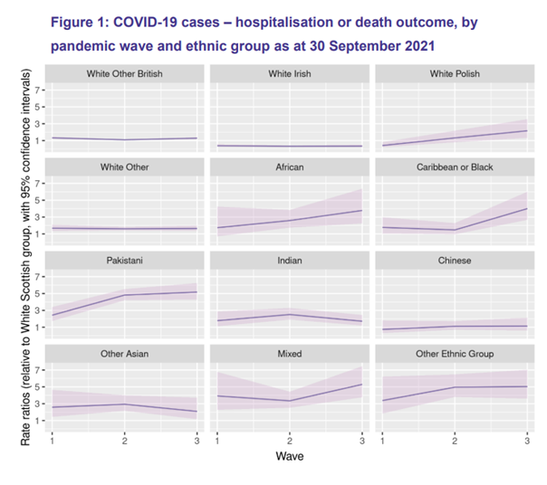

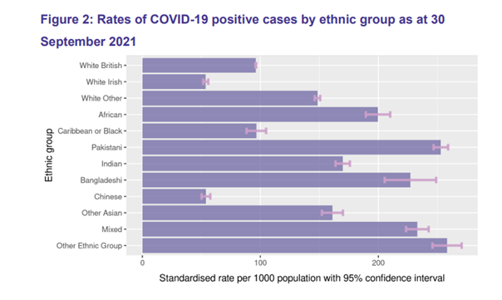

patient_ethnicity_description | vaccination | VaccinationsAdministered
African, Scottish African or British African | CVD Dose 1 | 2
Any Mixed or multiple ethnic group | CVD Dose 1 | 16
Bangladeshi, Scottish Bangladeshi or British Bangladeshi | CVD Dose 1 | 1
Caribbean or Black | CVD Dose 1 | 4
Chinese, Scottish Chinese or British Chinese | CVD Dose 1 | 9
Gypsy/Traveller | CVD Dose 1 | 3
Indian, Scottish Indian or British Indian | CVD Dose 1 | 5
Irish | CVD Dose 1 | 11
Opt out, Not known | CVD Dose 1 | 118
Other | CVD Dose 1 | 17
Other British | CVD Dose 1 | 382
Other ethnic group | CVD Dose 1 | 12
Other ethnic group Arab, Scottish Arab or British Arab | CVD Dose 1 | 3
Other white ethnic group | CVD Dose 1 | 104
Pakistani, Scottish Pakistani or British Pakistani | CVD Dose 1 | 4
Polish | CVD Dose 1 | 17
Roma | CVD Dose 1 | 2
Scottish | CVD Dose 1 | 3880
 | CVD Dose 1 | 1116
Total |  | 5706

patient_ethnicity_description | vaccination | VaccinationsAdministered
African, Scottish African or British African | CVD Dose 2 | 4
Any Mixed or multiple ethnic group | CVD Dose 2 | 26
Bangladeshi, Scottish Bangladeshi or British Bangladeshi | CVD Dose 2 | 1
Caribbean or Black | CVD Dose 2 | 5
Chinese, Scottish Chinese or British Chinese | CVD Dose 2 | 16
Gypsy/Traveller | CVD Dose 2 | 7
Indian, Scottish Indian or British Indian | CVD Dose 2 | 14
Irish | CVD Dose 2 | 50
Opt out, Not known | CVD Dose 2 | 597
Other | CVD Dose 2 | 27
Other British | CVD Dose 2 | 1951
Other ethnic group | CVD Dose 2 | 29
Other ethnic group Arab, Scottish Arab or British Arab | CVD Dose 2 | 2
Other white ethnic group | CVD Dose 2 | 208
Pakistani, Scottish Pakistani or British Pakistani | CVD Dose 2 | 7
Polish | CVD Dose 2 | 38
Roma | CVD Dose 2 | 2
Scottish | CVD Dose 2 | 13039
Showman/Showwoman | CVD Dose 2 | 1
 | CVD Dose 2 | 2321
Total |  | 18345

What we’ve done
Communication and literary needs of racial groups are increasingly supported through the Health In My Language web resource, for provision of written materials, and via NHS WI Service Level Agreement with Language Line, for simultaneous remote interpreting.
NHS Eileanan Siar has had this SLA with Language Line for thirteen years. Language Line provides interpreting services for over 240 languages. The benefits this service affords to healthcare cannot be underestimated, given the serious safety implications of inaccurate communication in clinical consultations.
The ground-breaking Language Line inSight interactive remote relay interpreting facility has expanded into usage of the InSight Interpreter on Wheels by NHSWI Physiotherapy at the end of 2021, in addition to usage of the InSight app on smartphones over 2021-22 by specialist nursing teams undertaking home visits. The agility of the InSight web resource across devices means that the communication needs of patients with diverse languages can be much better supported across domiciliary and primary care settings in addition to acute ones.

There are a number of NHS WI health information leaflets available in Polish and Latvian, as there are a large number of Polish and Latvian workers in the local community.

Following the groundwork laid by NHS Western Isles inaugural Gaelic Language Plan 2012-17, work has re-invigorated at pace on the second iteration of our GLP from 2023-28. It is planned that this will augment further harness the use & stature of Gaelic throughout the organisation. This logically reflects our location, as the Western Isles is the Gaelic heartland of Scotland, with the number of Gaelic speakers in the parish of Barvas recorded at 64 per cent in the 2011 Census. It is therefore appropriate that this cultural asset is harnessed in the activities & outcomes of the Health Board.
Since our last Equality Mainstreaming submission, 8 colleagues have undertaken Gaelic courses over 2021-22 by means of our Service Level Agreement with Lewis Castle College. These courses have expanded to not just consist of the Ùlpan course but also Speak Gaelic (in conjunction with the BBC Alba programme), Sgilean Cànain and, rather helpfully for employers such as ourselves, Gaelic for Work Purposes. This is an important part of the Staffing commitment of the GLP & reflects the Increasing the Use of Gaelic objective of the National Plan for Gaelic 2018-23. The NHSWI Operational Diversity Lead continues to provide Gaelic translation of written materials on request and has produced a wide range of Gaelic literature & posters in the areas of Infection Control, Dietetics, Health Promotion and Mental Health amongst others.
Being a Language Plan partner of Bòrd na Gàidhlig has afforded NHSWI the opportunity to submit bids annually to their Gaelic Language Act Implementation Fund (GLAIF).

The following charts show the ethnic mix in both recruitment and in employees of NHS Western Isles.

Workforce
Job Family | Asian - Other | % | Declined | % | Don't Know | % | Mixed or Multiple Ethnic Group | % | Other Ethnic Group | % | White Irish | % | White Other | % | White British | % | White Scottish | %
Administrative Services | 0 | 0.00% | 8 | 0.75% | 53 | 4.99% | <5 | * | 0 | 0.00% | <5 | * | <5 | * | 16 | 1.51% | 112 | 10.55%
Allied Health Profession | 0 | 0.00% | 7 | 0.66% | 10 | 0.94% | 0 | 0.00% | <5 | * | 0 | 0.00% | <5 | * | 13 | 1.22% | 60 | 5.65%
Dental Support | 0 | 0.00% | <5 | * | <5 | * | 0 | 0.00% | 0 | 0.00% | 0 | 0.00% | <5 | * | <5 | * | 41 | 3.86%
Healthcare Sciences | 0 | 0.00% | 0 | 0.00% | <5 | * | 0 | 0.00% | 0 | 0.00% | 0 | 0.00% | 0 | 0.00% | 6 | 0.56% | 16 | 1.51%
Medical and Dental | 0 | 0.00% | <5 | * | 11 | 1.04% | 0 | 0.00% | 0 | 0.00% | 0 | 0.00% | 8 | 0.75% | 6 | 0.56% | 8 | 0.75%
Medical Support | 0 | 0.00% | 0 | 0.00% | <5 | * | 0 | 0.00% | 0 | 0.00% | 0 | 0.00% | 0 | 0.00% | <5 | * | <5 | *
Nursing and Midwifery | 0 | 0.00% | 25 | 2.35% | 106 | 9.98% | <5 | * | 0 | 0.00% | <5 | * | <5 | * | 27 | 2.54% | 300 | 28.25%
Other Therapeutic | 0 | 0.00% | 0 | 0.00% | 7 | 0.66% | 0 | 0.00% | 0 | 0.00% | <5 | * | <5 | * | <5 | * | 8 | 0.75%
Personal and Social Care | 0 | 0.00% | <5 | * | <5 | * | 0 | 0.00% | 0 | 0.00% | <5 | * | 0 | 0.00% | 0 | 0.00% | 12 | 1.13%
Senior Managers | 0 | 0.00% | 0 | 0.00% | <5 | * | 0 | 0.00% | 0 | 0.00% | 0 | 0.00% | 0 | 0.00% | 0 | 0.00% | <5 | *
Support Services | <5 | * | <5 | * | 15 | 1.41% | 0 | 0.00% | <5 | * | 0 | 0.00% | 5 | 0.47% | 15 | 1.41% | 122 | 11.49%

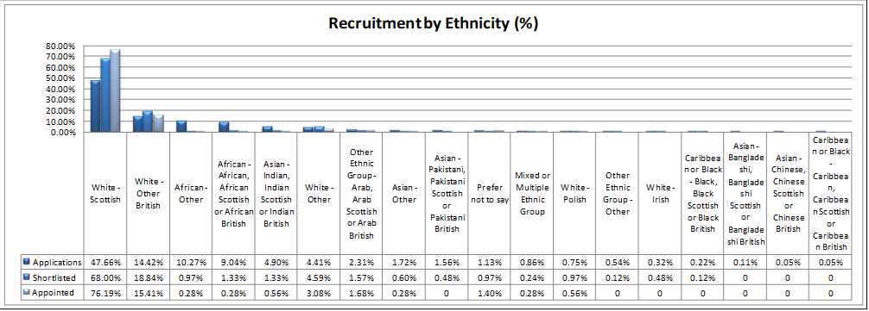

4.2 SEX

Outcome
Sensitive practice to be extended around gender-specific needs and conditions.

Rationale
In the 2011 Census, 49.4 per cent of the Western Isles population was male, while 50.6 per cent was female.

Breast cancer is the most common cause of cancer in women in Scotland. Lung and colorectal cancers are the most common causes of cancer in men, followed by prostate cancer. The Scottish Public Health Observatory reports that women have a generally less positive experience than males as inpatients, but that regarding health help-seeking behaviour, men consult their GP less often than women and are more likely to attend an emergency department.

Regarding domestic abuse, there were 64,807 of domestic abuse incidents recorded by Police Scotland over 2021/22. Common Assault was the most frequently recorded offence, comprising 32% of all crimes and offences. Many women never report the abuse to the police, so there is a hidden dimension to the issue that is disturbing. The new offences of coercion, control and abuse enacted in the 2019 Domestic Abuse (Scotland) Act accounted for 4% of all crimes and offences over 2021-22.
The 31 to 35 years old age group had the highest incident rate for both victims and perpetrators over this period. A third of the recorded incidents took place over a weekend.

Of the 753 suicides in Scotland recorded by the Scottish Public Health Observatory in 2021, 565 were males and 188 were females. The probable suicide rate (both crude and age-sex standardized) in the period 2017 - 2021 was over three times higher in the most deprived areas compared to the least deprived areas.

What we’ve done

Building on the Equally Safe Delivery Plan for Scotland 2017-21 published by the Scottish Government and COSLA, the Equally Safe Short Life Delivery Plan was published in 2022, to take up to the autumn of 2023. This refreshed interim Delivery Plan contains 33 actions across four overarching priorities, taking account of the post-COVID landscape, the growing focus on misogyny and the findings of the Violence Against Women and Girls: Strategic Review of Funding and Commissioning Services.

The Short Life Delivery Plan is embedded here:-

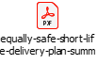

NHSWI is a committed member of the dynamic multi-agency Violence Against Women Partnership forum. The coalescing of resolve and insights within the Partnership in relation to public awareness and safety around this are constantly informing a culture of quality improvement and learning, which was agile to the impact of COVID-19 in the community. This can be seen in the Equally Safe Quality Standards Local Area Report 2021-22 for the Western Isles. This is embedded here:
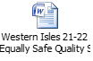

In relation to MARAC, this was introduced to the Western Isles in April 2016, following a period of development by the Domestic Abuse Forum. NHS Western Isles is a key member of the group.
A MARAC is a meeting where information is shared about the highest risk domestic abuse cases between representatives of local agencies. After sharing all relevant information, they have about a victim, the representatives discuss options for increasing the safety of the victim and turn these into a coordinated action plan. The primary focus of the MARAC is to safeguard the adult victim. At the heart of a MARAC is the working assumption that no single agency or individual can see the complete picture of the life of a victim, but all may have insights that are crucial to their safety.
The MARAC data for 2021-22 is shown here. The number of cases in the archipelago has more than doubled from those o the previous year. In all cases women were identified as the victims of domestic abuse. The number of children affected within households has risen again close to 2019-20 levels. All cases discussed have generated an increase in actions taken to improve the safety of victims and their children and mitigate the risks posed by the perpetrator. This data is shown in the table on the next page.

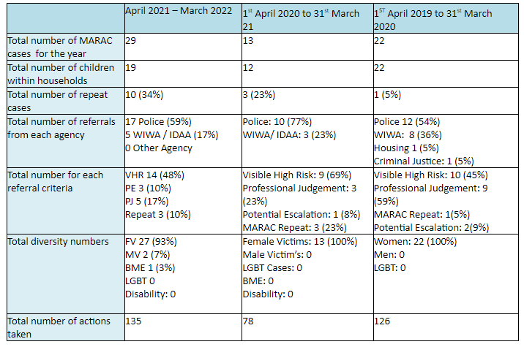

It is important to state here that NHSWI has its own Gender-Based Violence Policy within the suite of their Human Resources policies, to provide a framework for delivering support to employees of the organization who are experiencing domestic abuse. In connection with raising awareness of domestic abuse in the workforce, the major employers in the Western Isles, including NHS Eileanan Siar, plan to re-activate post-COVID the 16 Days of Action Against Domestic Abuse campaign from November to December 2022. The Western Isles Violence Against Women Partnership is the major local mobilising force to promote this worldwide initiative.
NHSWI is one of the coalition of agencies that contribute to the vital lifeline provided by Western Isles Womens’ Aid in Stornoway for women and children fleeing domestic abuse. Having had a presence in the town for many years, they are now based in a much better building with superior facilities. They offer support, someone to talk to and information on benefits, legal advice and housing options. They also provide one to one counselling and telephone counseling, a safe and secure space way from the abuser with a direct link to the Police Station and support for women and children who have left a mainland refuge to return to the Western Isles. Being part of a national network of 35 refugees across Scotland is also a considerable advantage in terms of access to expert advice and resources.

In relation to the field of mens’ health, NHS Western Isles has been proud to be a key partner of the Hebridean Mens’ Cancer Support Group. The Group celebrated its tenth anniversary in 2018, having been set up in 2008. The Support Group is now back to meeting in person at the Fàilte Centre in Stornoway, following the switching to a remote online forum discussion at the onset of the pandemic.
The Support Group addresses every new diagnosis in the Western Isles, sending a welcome pack containing introductory leaflets about the group, as well as the benefits available from Macmillan Cancer Support. The launching of the Western Isles Cancer Care Initiative has been a most welcome development too in recent years, and the Support Group has forged a strong partnership with them. Men diagnosed with cancer can apply for grants of up to £500 from the WICCI’s Social Fund, which the Support Group can signpost to. The opening of the WICCI’s premises in Cromwell Street has now provided a much-needed tranquil well-being space for people with cancer and their families. A number of complementary therapies & access to counsellors are to be found there.

NHS Western Isles is an Equal Opportunity Employer, and, as a Public Authority in Scotland, we have to, in compliance with both the Equalities Act 2010 and the (Specific Duties) (Scotland) Regulations 2012, work towards a workforce that is representative of the organisation and shows equal opportunity of advancement i.e. our promoted posts should be as near as possible to the ratio of males and females in our organisation.

The charts below show the number of male/female Whole Time and Part Time Equivalent staff in the organization, our male/female ratios across Job Families and Recruitment by Gender.

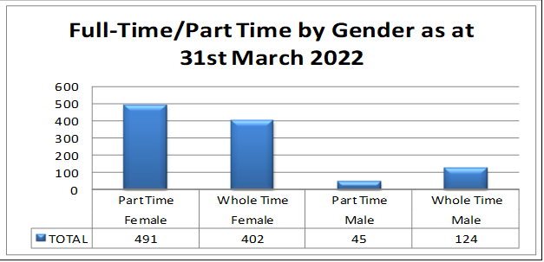

Job Family | Female Employments | % | Male Employments | %
Administrative Services | 164 | 15.44% | 31 | 2.92%
Allied Health Profession | 80 | 7.53% | 13 | 1.22%
Dental Support | 46 | 4.33% | <5 | *
Healthcare Sciences | 19 | 1.79% | 5 | 0.47%
Medical and Dental | 12 | 1.13% | 24 | 2.26%
Medical Support | <5 | * | <5 | *
Nursing and Midwifery | 437 | 41.15% | 27 | 2.54%
Other Therapeutic | 17 | 1.60% | <5 | *
Personal and Social Care | 14 | 1.32% | <5 | *
Senior Managers | <5 | * | <5 | *
Support Services | 102 | 9.60% | 58 | 5.46%

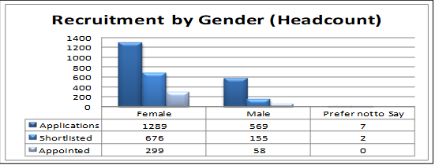

The next charts show the proportion of male/female in posts A4C grade 7 and above, including staff not employed under Agenda for Change terms.

Agenda for Change Staff
Job Family | Band | Female Employments | Male Employments | Gender Pay Gap Male to Female % | Total Employments
Admin Services | Band 7 | 5 | 8 |  | 13
 | Band 8A | 3 | 1 |  | 4
 | Band 8B | 4 | 1 |  | 5
 | Band 8C | 1 | 1 |  | 2
 | Band 8D | 0 | 1 |  | 1
Allied Health Professions | Band 7 | 13 | 2 |  | 15
 | Band 8A | 3 | 1 |  | 4
 | Band 8B | 3 | 0 |  | 3
 | Band 8C | 0 | 0 |  | 0
 | Band 8D | 0 | 0 |  | 0
Healthcare Sciences | Band 7 | 3 | 1 |  | 4
 | Band 8A | 0 | 0 |  | 0
 | Band 8B | 0 | 1 |  | 1
 | Band 8C | 0 | 0 |  | 0
 | Band 8D | 0 | 0 |  | 0
Medical & Dental Support | Band 7 | 3 | 0 |  | 3
 | Band 8A | 0 | 0 |  | 0
 | Band 8B | 0 | 0 |  | 0
 | Band 8C | 0 | 0 |  | 0
 | Band 8D | 0 | 0 |  | 0
Nursing & Midwifery | Band 7 | 58 | 3 |  | 61
 | Band 8A | 4 | 0 |  | 4
 | Band 8B | 7 | 0 |  | 7
 | Band 8C | 1 | 1 |  | 2
 | Band 8D | 0 | 0 |  | 0
Other Theraputic | Band 7 | 4 | 1 |  | 5
 | Band 8A | 2 | 0 |  | 2
 | Band 8B | 0 | 0 |  | 0
 | Band 8C | 2 | 1 |  | 3
 | Band 8D | 0 | 0 |  | 0
Personal & Social Care | Band 7 | 1 | 1 |  | 2
 | Band 8A | 0 | 0 |  | 0
 | Band 8B | 0 | 1 |  | 1
 | Band 8C | 0 | 0 |  | 0
 | Band 8D | 0 | 0 |  | 0

Support Services | Band 7 | 0 | 1 |  | 1
 | Band 8A | 0 | 0 |  | 0
 | Band 8B | 0 | 1 |  | 1
 | Band 8C | 0 | 0 |  | 0
 | Band 8D | 0 | 0 |  | 0

Non Agenda for Change Staff
 | Female Employments | Male Employments | Gender Pay Gap Male to Female % | Total Employments
Medical Staffing | 7 | 12 |  | 19
Dental | 3 | 9 |  | 12
Executive Level | 2 | 1 |  | 3

4.3 Equal Pay

An integral part of the Equality Act 2010 (Specific Duties) (Scotland) Regulations 2012 is a number of measures to monitor public bodies to ensure that there is no gender inequality in their pay rates.
Measures include:
- A requirement to publish every two years from 30th April 2013 onwards information on any Gender Pay Gap. This information should be shown as any difference between the mens’ average hourly pay (excluding overtime) and womens’ average hourly pay (excluding overtime).
- The information published must be based on the most recent data available.

In line with the General Duty of the Equality Act 2010, our objectives are to:
- Eliminate unfair, unjust or unlawful practices and other discrimination that impact on pay equality.
- Promote equality of opportunity and the principles of equal pay throughout the workforce
- Promote good relations between people sharing different protected characteristics in the implementation of equal pay.

The NHS Eileanan Siar Equal Pay Statement for 2021 can be found in Appendix 1 at the end of this Report.

Gender Pay Gap Analysis

NHS Western Isles employ staff on different sets of nationally agreed terms and conditions. We carried out analysis of womens’ and mens’ pay within each pay band of the Agenda for Change (AFC) Medical and Dental and the Senior Managers’ contract groups. Through these arrangements posts are graded, not the individual. There is no evidence that gender informs the level of pay for any post within NHS Western Isles.
There were overall more female employees than male with AfC and Senior Manager terms and conditions and more male than female with Medical and Dental terms and conditions. This related to our substantive workforce and did not include temporary cover/locum arrangements.
There is some evidence of gender occupational segregation within NHS Western Isles, with women more likely to work in traditional caring roles and administration routes.

Gender Pay Gap Analysis Tables 2021-22

Mean Gender Pay Gap | 16.44% |  | Due to high proportion of Medical Consultants being Male at the snap shot date
Median Gender Pay Gap | 0.00%
Mean Bonus Gender Pay Gap | N/A |  | No Bonus Paid
Median Bonus Gender Pay Gap | N/A |  | No Bonus Paid
Proportion of Males and Females receiving bonus | N/A |  | No Bonus Paid
Proportion of males and females in each quartile band
Lower Male | 19.20%
Lower Female | 80.80%
Lower Middle Male | 13.78%
Lower Middle Female | 86.22%
Upper Middle Male | 20.31%
Upper Middle Female | 79.69%
Upper Male | 18.14%
Upper Female | 81.86%

4.4 DISABILITY

Outcome
We will engage and work with our patients & staff as diligently as possible to improve the experience of care and to enhance physical access.

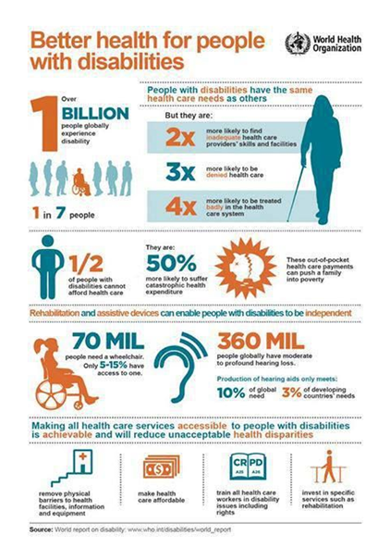

Rationale

The 2011 Census showed that one in five people in Scotland reported a long-term health problem or disability. This is more or less replicated in the 2011 Census results in the Western Isles, where a percentage of 20.5per cent reported having a long-term life-limiting problem or disability. As healthcare patients, there is also the dimension of co-morbidity of disabling conditions that requires planning and treatment.
The causal link between disability and penury can be seen in the Scottish Government’s findings that households in which one or more disabled person resides is likely to have no working members and to be at greater risk of financial difficulties. In the workplace, disabled employees are more likely than non-disabled ones to face barriers to work because of lack of confidence and attitudes of employers.

The impact of the COVID-19 pandemic on those with a disability throughout the UK has been singularly disproportionate in comparison with the general population. This has been soberly examined in the United Nations Convention on the Rights of Disabled People Scottish Civil Society Shadow Report of March 2022. It identified key issues around the implementation of the UNCRPD in Scotland. The arrival and impact of Covid-19 and the consequences of the ensuing pandemic have revealed the deep-rooted inequalities in Scotland that existed before Covid-19 arrived. These inequalities have widened, as economies, households and public services locked down to contain the spread of the virus, as the Report illuminates from the narratives of those who responded. . The virus and its outcomes did not of themselves create inequalities, but rather they exacerbated the structural inequalities and intersecting oppressions of discrimination and disadvantage faced by disabled people in Scotland today.
The main Report and the Easy Read version are embedded here:-

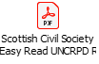

It is important not to lose sight of the fact that many disabilities are hidden in plain sight. 93% of disabled people don’t use a wheelchair. Under the provisions of the Equality Act, depression is classed as a life limiting disability.

What we’ve done

British Sign Language
Developments in BSL provision in NHSWI over 2017-18 have been informed by the historic British Sign Language (Scotland) Act 2015 and the subsequent BSL National Plan for Scotland 2017-23. These have made Scotland the first country in the UK to recognise BSL as a language in law, with all the rights, privileges and protections this affords. The Act is a major catalyst in dismantling the barriers to participation in civic life that BSL users, & indeed the deaf community as a whole, have endured for so long.
Tailoring the BSL National Plan to local needs & circumstances led to the milestone of NHSWI’s first ever BSL Plan being assembled & then approved in May 2019. This carries up to 2024 It’s contextualisation of the local priorities has been acknowledged and welcomed by the BDA Scotland.
The NHSWI BSL Plan can be viewed here:-

Crucially with regard to correcting a historic injustice around access to BSL interpreting in NHS Eileanan Siar, since the purchase of the LanguageLine Insight Interpreter On Wheels unit as described earlier in this Report, BSL video interpreting is available on demand between 9-5 Monday to Friday. This has made a huge difference to BSL speakers in receipt of care because of the lack of suitably qualified BSL interpreters locally.
The service has been exhorted to our associates at the Western Isles Sensory Centre, run jointly by the Highland Sensory Project and Sight Action. This is a key supportive space & equipment repository for people in the archipelago with a sensory impairment. The Lewis and Harris Deaf Club did meet regularly there prior to the COVID-19 pandemic, but the enforced incarceration for such a long period has contributed to it not resuming physical gatherings.
Improved Deaf Awareness, incorporating simple things we can all do, is increasingly important for employees in both the public and private sector. A member of NHSWI with a hearing impairment is keen to take this forward for the benefit of all staff.
The launch of this video relay interpreting service, along with the clear benefits of collaboration with our associates at the WI Sensory Centre, shows clearly how a local BSL Plan gives impetus towards the commissioning of such assets.
The NHSWI Audiology Service currently consists of one Practitioner, resulting in a very heavy workload for them This in turn is leaving a built-in vulnerability in the service, with very long waiting lists for hearing assessments and sourcing replacements for staff sickness. Solutions to this issue are currently being explored.

Inaccessible information is one of the main comprehension barriers that individuals with a learning disability encounter when interacting with health services. Documents presented in the Easy Read graphical format are one of the best ways of improving the understanding of this client group when they and their carers require guidance or wish to take part in consultations. Accordingly, NHSWI in 2021 added a suite of Easy Read documents for the benefit of this client group on our public website. These are arranged by Your Health Information, Local Services, National Services, Autism Information, Professional Toolkit and Strategies/Policies.
These aspirations will benefit Advocacy Western Isles especially. This organisation provides issue-based one-to-one, non-instructed and collective independent advocacy support to individuals in need throughout the Western Isles. Priority is given to those with mental health issues, people with a learning disability, older people, children and young people and parent/carers. It currently provides specialist advocacy for mental health which works closely with legal services for individuals who are subject to statutory measures. It also works with individuals with a diagnosis of mental illness and any other undiagnosed mental illnesses such as depression.
The Speak Out Group (formerly known as the Stand Up for Yourself Self Advocacy Group) have met with Advocacy Western Isles since 2006. The Speak Out Group are a well-established advocacy group of adults with learning disabilities who get together at least once per month to deal with issues in the community that concern people with learning disabilities and that are of interest to people with learning disabilities. The group has given their views in conjunction with Western Isles ENABLE in response to Transport Scotland’s request for further information on any potential extension to the eligibility criteria for the Blue Badge Scheme to include people who as a result of a diagnosed mental disorder have little or no awareness of danger from traffic. They have also provided feedback on how health consultations and the overall hospital experience can be improved for people with learning disabilities. This has led to discussion about more suitable information leaflets for x-rays and scans.
The increasing confidence of the Speak Out Group in relation to influencing towards better services is demonstrated in them providing the Foreword to the Western Isles Health and Social Care Partnership’s Learning Disability Strategy 2019-22. As a local response to the national Keys to Life learning disability strategy the key role the NHS plays in providing succor and support is acknowledged within it.
The Strategy can be viewed here:
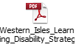
The Autism Eilean Siar Support Group meets is a dynamic forum in the archipelago. This provides support & raises awareness for the parents of children with conditions on the autism spectrum disorder. The group is back to holding face to face support group meetings in the Failte Centre. The Group is also back to running full group activities for children and adults affected by additional support needs and did so as soon as restrictions allowed.

The Support Group report how COVID was extremely difficult hard for parents. As the group is run by parents whose children have additional support needs, it was very challenging to run support sessions by Zoom. Parents were struggling with home schooling and simply didn't have time or had time to to take part in frequent Zoom meetings, as children with demanding additional needs needed their constant support in the contained pressure cooker environment of the acute infection suppression restrictions. The few that were held only had small numbers. Support was given more effectively, it was found, through email and the Group social media platforms.
In terms of activities for children the Core Committee delivered activity packs to families throughout Lewis and some to Uist. These packs included activities specific to individual needs, arts and crafts, life skills, sensory etc. Deliveries were made to members' doors monthly throughout the pandemic.
When restrictions eased, fun sessions were run in Sandwick Hall. These were split into three groups to keep the numbers manageable. Two to three trustees stuck to that group, deploying a booking system. The booking system was also adopted for the monthly drop-in support sessions for parents and carers.
NHS Western Isles staff, such as Health Visitors and School Nurses, refer children to the Support Group subsequent to anomalies being picked up on the Universal Health Visiting Pathway. Work step and Capability Scotland assisted schemes are in place for the provision of financial assistance for the procurement of aids and adaptations to enable supported employment for appropriate employees in NHS Western Isles.
Set up in 2022, the Disability Advocacy Collective (DAC) is a new local group that deals with issues around services for children and adults with care needs throughout Lewis, Harris, Uist and Barra. The DAC is a collective advocacy group with Advocacy Western Isles and is made up of the Speak Out Group for adults with learning disabilities, the local Enable Group, Autism Eilean Siar, The Harris Disability Access Panel and individuals who require social care services for whatever reason, their carers and anyone with an interest in Social Care.
The DAC came about because families who care for people with disabilities, the elderly, people with dementia and people with any kind of additional support needs started to share their stories. The DAC wish to be involved in resolving such issues and want to support each other while doing so. They would:
- like to try to have seamless transitions from children's services to adult services.
- wish to not have to worry so much about those they care for having no other option available to them than going to the mainland for residential care.
- hope to try and find answers to the concerns parents, carers and people who are cared for have about future planning.
- welcome plans that tell them there are services available for their loved ones when they are no longer able to provide the care needed due to age or circumstances out with their control.
- appreciate access to services that allow people to receive good care at home and in their community.
- like to remain on the islands.
- wish to return to the islands.
- like to try to receive equity of travel to services throughout the islands and in our dispersed communities.
- be grateful for respite services that meets their needs.
The DAC want to work with Comhairle nan Eilean Siar, NHS Western Isles, the Third Sector and any other relevant agencies both locally and nationally in an open and respectful manner. The DAC wish to ensure the issues highlighted remain on the table and are worked on until resolutions are reached to the benefit of those who need the care and those who provide it. They would like to have confidence in planning for the future. The DAC is very fortunate to have 10 CnES elected councillors who engage with the DAC regularly, giving support and advice which has been invaluable. The DAC met with candidates prior to the recent council local election and received offers of support from new councillors. The DAC was heartened by this. The councillors raise issues on behalf of the DAC at council meetings when required. They have told the DAC they really welcome the chance hearing about the different experiences people encounter when they require care services.

The following charts show our ratio of staff with disabilities across the Job Families and Recruitment by Disability.

Job Family | Don't Know | % | Yes | % | No | % | Declined | %
Administrative Services | 87 | 8.19% | <5 | * | 104 | 9.79% | <5 | *
Allied Health Profession | 30 | 2.82% | 0 | 0.00% | 60 | 5.65% | <5 | *
Dental Support | 17 | 1.60% | 0 | 0.00% | 29 | 2.73% | <5 | *
Healthcare Sciences | 5 | 0.47% | <5 | * | 17 | 1.60% | <5 | *
Medical and Dental | 15 | 1.41% | 0 | 0.00% | 20 | 1.88% | <5 | *
Medical Support | <5 | * | 0 | 0.00% | <5 | * | 0 | 0.00%
Nursing and Midwifery | 180 | 16.95% | <5 | * | 268 | 25.24% | 14 | 1.32%
Other Therapeutic | 7 | 0.66% | 0 | 0.00% | 13 | 1.22% | 0 | 0.00%
Personal and Social Care | 7 | 0.66% | 0 | 0.00% | 9 | 0.85% | <5 | *
Senior Managers | <5 | * | 0 | 0.00% | 0 | 0.00% | 0 | 0.00%
Support Services | 44 | 4.14% | <5 | * | 114 | 10.73% | <5 | *

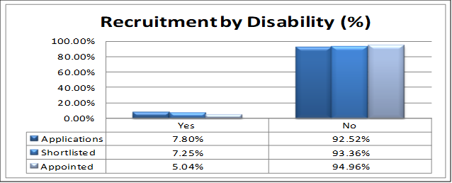

4.5 RELIGION AND BELIEF

Outcome
We will provide Spiritual Care within a professional framework to NHS WI patients and staff, to enable the finding of hope, meaning and comfort to those of all faiths and beliefs in addition to those of none, upholding respect and their dignity at all times.

Rationale
There can be no doubt that the need to make sense of one’s circumstances becomes more pressing in times of illness. This desire does not only reside within the patient, but in their loved ones, who seek at least a listening ear, not just answers, in their distress. In serving the needs and aspirations arising from these concerns, spiritual care, as expressed through pastoral support, adds value to the whole organisation. This coming alongside people also impacts positively on staff morale, with the compassion and advocacy inherent in spiritual care mitigating strife and stress in the workplace.

Research conducted by the European Centre of Social Welfare Policy in 2013 showed that people with a faith or belief were better able to cope with shocks such as losing a job or divorce and had higher levels of life satisfaction. Taking this wider to the exercise of Chaplaincy pastoral support to those of all faiths and none, Kirshnakumar and Neck (2002) suggested that the encouragement of spirituality in the workplace can lead to benefits in the areas of creativity, honesty, personal fulfilment and commitment, which will ultimately lead to increased organisational performance.

The legacy of the well-recorded Christian faith traditions of the Western Isles, both Protestant and Catholic, can be seen in the 2011 Census results, in which the archipelago had the lowest percentage of people in Scotland saying they had no religion, at 18.1 per cent, in comparison with the Scottish average of 36.7per cent. The Outer Hebrides also had the highest percentage of people stating that their religion was Other Christian (from the Church of Scotland), at 19.1per cent. However, nationally as a whole, increases in the Census of people recording a non-Christian affiliation in Scotland – with the largest religious group in this sphere, Muslims, increasing by 80 per cent from 2001 to 77,000 people – demonstrates how important it is for accommodation, sensitivity and respect to be given to the needs of all faiths who converge on the service.

What we’ve done

Spiritual Care in the NHS throughout Scotland is currently being guided by the pillars of the Person-Centred Care approach. These four dimensions are Leadership, Care Experience, Staff Experience and Co-Production. This is a way of operating in which value is invested in each individual and what matters to them.
Openness and responsiveness to all is at the heart of the NHS Western Isles Spiritual Care Policy. Underpinned by this, the Chaplaincy service at NHS Western Isles consoles those of all faiths or none. This heterogeneous approach is underpinned by the CEL 2008 on Spiritual Care.

This need to promote inclusion within NHS Western Isles can be seen in the variety of faith groups that patronise the sanctuary. Regrettably the weekly Christian Protestant service that was held in the Sanctuary every Sunday morning and that was so appreciated by in-patients with a church connection ceased at the start of the pandemic, as did the monthly Roman Catholic service and the Saturday Ba’hai gathering. It is hoped to re-commence these when it is safe to do so. In the interim patients on the wards are being supported to access their own congregational service live streams on the Sunday remotely, using the iPads distributed round the wards for the Virtual Visiting initiative. Muslim members of staff remain free to use the Sanctuary as an individual prayer space when required. . A Muslim prayer mat was purchased a few years ago, and this is provided for Muslim prayer requirements.

The sanctuary is also used as a quiet room for staff to use at any time, should they wish a tranquil space for reflection and calm. This is particularly appreciated in times of stress, such as bereavement. The move of the Spiritual Care & Diversity Department to its current location in 2017 in the former Acute Psychiatry Group Therapy room has benefited the weekly Sunday morning service, in that greater numbers are coming to it in the new Sanctuary. Since its refurbishment for an explicit Spiritual Care Purpose, the area is now compliant with faith observation requirements in a way that it was not in the old Chapel, particularly by the installation of appropriate ablution facilities for Muslim staff & patients in the enlarged bathroom. The presence of a toilet facility is also beneficial for elderly patients attending the Sunday service.

The Bereavement Support Group run by the NHSWI Chaplains that was set up in 2018 was suspended at the start of the pandemic and has not yet re-convened. It is hoped to resurrect this when it is safe to do so.

The Community Chaplaincy Listening Service has been running for 10 years now, following a successful pilot project. It is carried out within a pastoral care framework by the trained Chaplaincy Listener, who provides this in the different GP surgeries. It enables people who have been attending their GPs’ to help themselves by identifying assets and resources within themselves, via the telling of their story in a series of sessions. The impact of the service can be seen in that there has been a reduction in inappropriate GP appointments, an increase in patients’ capacity to cope with challenging circumstances and a bolstering of community resilience.
At the onset of the pandemic CCL switched to a telephone format but has now reverted back to the pre-COVID service of GP surgery consultations.

The very successful Values Based Reflective Practice support model for team cohesion difficulties as deployed by the Chaplains has evolved and adapted since the onset of the pandemic to an outreach with individuals in addition to that with teams. The I See, I Wonder and I Realise verbatim intrinsic to VBRP was found to be of huge benefit as a lit pathway to members of staff who were under significant levels of strain and stress with the clinical burden on them at the height of the pandemic, when case numbers were so high. It is therefore a most positive development that a level of agility, spontaneity even, is further developing the VBRP approach so that it is flexing to the pace of events and unexpected challenges.

The following charts show the demarcation of religious and faith affiliations across our Job Families and Recruitment by Religion.

Job Family | Buddhist | % | Christian - Other | % | Church of Scotland | % | Declined | % | Dont Know | % | Hindu | % | Muslim | % | No Religion | % | Other | % | Roman Catholic | %
Administrative Services | <5 | * | 24 | 2.26% | 65 | 6.12% | 13 | 1.22% | 50 | 4.71% | 0 | 0.00% | 0 | 0.00% | 30 | 2.82% | <5 | * | 9 | 0.85%
Allied Health Profession | 0 | 0.00% | 18 | 1.69% | 28 | 2.64% | 12 | 1.13% | 10 | 0.94% | 0 | 0.00% | 0 | 0.00% | 14 | 1.32% | <5 | * | 9 | 0.85%
Dental Support | 0 | 0.00% | 9 | 0.85% | 20 | 1.88% | <5 | * | <5 | * | 0 | 0.00% | 0 | 0.00% | 7 | 0.66% | <5 | * | 5 | 0.47%
Healthcare Sciences | 0 | 0.00% | <5 | * | 8 | 0.75% | <5 | * | <5 | * | 0 | 0.00% | 0 | 0.00% | 7 | 0.66% | 0 | 0.00% | 0 | 0.00%
Medical and Dental | 0 | 0.00% | 7 | 0.66% | <5 | * | <5 | * | 7 | 0.66% | <5 | * | <5 | * | 9 | 0.85% | 0 | 0.00% | 5 | 0.47%
Medical Support | 0 | 0.00% | 0 | 0.00% | <5 | * | 0 | 0.00% | <5 | * | 0 | 0.00% | 0 | 0.00% | 0 | 0.00% | <5 | * | 0 | 0.00%
Nursing and Midwifery | <5 | * | 80 | 7.53% | 166 | 15.63% | 46 | 4.33% | 92 | 8.66% | <5 | * | 0 | 0.00% | 36 | 3.39% | 5 | 0.47% | 37 | 3.48%
Other Therapeutic | 0 | 0.00% | 0 | 0.00% | <5 | * | <5 | * | 7 | 0.66% | 0 | 0.00% | 0 | 0.00% | 5 | 0.47% | <5 | * | 5 | 0.47%
Personal and Social Care | 0 | 0.00% | <5 | * | <5 | * | <5 | * | <5 | * | 0 | 0.00% | 0 | 0.00% | <5 | * | 0 | 0.00% | 6 | 0.56%
Senior Managers | 0 | 0.00% | 0 | 0.00% | <5 | * | <5 | * | 0 | 0.00% | 0 | 0.00% | 0 | 0.00% | 0 | 0.00% | 0 | 0.00% | 0 | 0.00%
Support Services | <5 | * | 26 | 2.45% | 66 | 6.21% | 11 | 1.04% | 17 | 1.60% | <5 | * | 0 | 0.00% | 26 | 2.45% | <5 | * | 9 | 0.85%

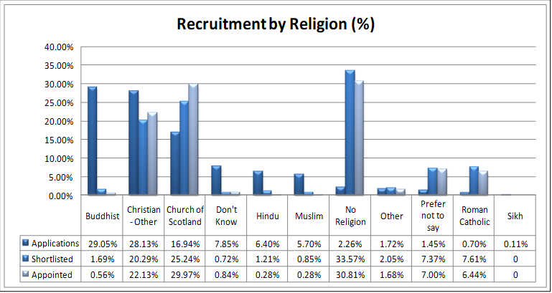

AGE

Outcome
NHS Western Isles will listen to the views of the young and the old who access our services and will promote the importance of dignity and respect for staff who work with them, in a way that identifies barriers and challenges.

Rationale
The 2011 Census showed that, in some age groups, the difference between the sexes was significantly marked in the Outer Hebrides. Up to the age of 65 there were more males than females, particularly in the 16-30 age group. However, from the age of 66 onwards, there were more females than males at every age apart from age 69 and 72.
Generally, epidemiology has revealed that health issues tend to be greater amongst the very young and the very old. The Census showed that there was a much higher level of disability in people aged 65 years or over in Scotland, and that four fifths of people aged 85 years and over reported that their day-to-day activities were limited by health problems or disability.

On 16 March 2021, the Scottish Parliament unanimously passed the United Nations Convention on the Rights of the Child (Incorporation) (Scotland) Bill (‘the Bill’). The Bill is a landmark piece of legislation that aims to incorporate the UNCRC into Scots law to the maximum extent of the Scottish Parliament’s powers – signaling a revolution in children’s rights in Scotland. The Bill seeks to empower our children and young people to claim their rights and help to make Scotland the best place in the world to grow up.
However, on 12 April 2021, a reference of certain provisions of the Bill was made by UK Law Officers to the UK Supreme Court. The provisions referred to the Supreme Court were section 6 (duty on public authorities) and sections 19 to 21 (the interpretation duty and judicial powers of ‘strike down’ and ‘incompatibility declarator’). A hearing before the UK Supreme Court took place on 28 and 29 June 2021. On 6 October 2021, the UK Supreme Court judgment on UNCRC (Incorporation) (Scotland) Bill found each of the provisions referred by the UK Law Officers to be out with the legislative competence of the Scottish Parliament.
While the judgement means that the Bill could not receive Royal Assent in its current form, the majority of work n relation to the implementation of the UNCRC can proceed and is continuing.
Childrens’ services in the archipelago have been significantly shaped recently by the Integrated Childrens’ Services Plan 2020-23, produced by the Outer Hebrides Children and Young People Planning Partnership (CYPPP). NHS Western Isles is a significant partner in relation to this. This adopts a human rights aware, anti-poverty focused approach, integrating early intervention, the importance of trauma awareness and island proofing.
It is embedded here:

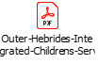

If we turn to a major mental health concern, suicide is the leading cause of death among young men in Scotland. In Scotland over 2019, the Samaritans reported that the suicide rate amongst young people aged between 15 and 24 increased by 52.7% from the previous year. This is the highest it has been since 2007.

What we’ve done

NHSWI clinicians who work with children follow the Getting it Right for Every Child framework National Practice Model. This is also adhered to by the local authority staff who work with children. This provides a foundation for identifying concerns, assessing needs and risks and making plans for children in all sectors of treatment. The NHSWI Lead Nurse Public Protection has made a significant contribution to improving our safeguarding, risk management and welfare support procedures. She works closely with the Child Health Commissioner and the Scottish Childrens’ Reporter for the locality.

The NHS Western Isles Specialist Child and Adolescent Mental Health Service (CAMHS) Team (Tier 3/4) sees children, young people (0-18, though this can be extended to 25 in specific protected groups if more appropriate), and their families with a wide range of mental health difficulties. Its aim is always to help the people they work with to understand the factors that lead to mental health problems, while working to stop these factors leading to further difficulties.
The Specialist CAMHS team has expanded in response to patient need, and includes a Consultant Child Psychiatrist, a Consultant Clinical Psychologist, Child and Adolescent Nurses, Child and Adolescent Mental Health Workers, a Social Worker, an Occupational Therapist, and a CAMHS/Learning Disabilities Link Nurse. Specialist CAMHS clinicians work within the framework of the Mental Health Act (2003, updated 2015); The Mental Health of Children and Young People: A Framework for Prevention, Promotion and Care (2005); and the Getting It Right For Every Child (GIRFEC) National Practice Model Framework as highlighted above. It is through a robust GIRFEC assessment of need that referrals to CAMHS would be indicated.
Over the last 5 years, NHSWI Specialist CAMHS has received an average of around 150 new referrals every year and issued an average of 1171 appointments each year.
Out with the above activity, CAMHS undertake further intervention and consultation at lower tiers. Since 2018 the demand for lower tier activity around mental wellbeing and emotional health has increased greatly. Between 2020 and 2022 an increase of 313% has been recorded within the Primary Care CAMHS. These referrals are directed from GPs, schools, and third sector agencies. To support the lower tier activity, a Community Mental Health Worker is committed to training and mentoring colleagues across children’s services.
In the last year, a new strategic group has been established in order to simplify and implement a new inclusive Neurodevelopmental pathway. This pathway aims to improve access to expert assessment and early intervention.
In relation to national CAMHS outcomes, NHSWI has consistently met the Scottish Government 18 week waiting time target for referral to treatment. Throughout the COVID-19 restrictions, this was achieved through adapting practice to deliver remote services using Near Me, though where a face-to-face consultation was indicated, this was given. As restrictions relaxed, face to face consultations increased and where possible, patients are given a choice on preferred appointment type. This has allowed CAMHS to continue to operate across all of the Western Isles, reducing the geographical challenges.

Advocacy Western Isles’ Children and Young Persons Independent Advocacy Project, which was established in 2006, is a key multi-agency partner with NHSWI in the field of child welfare. Advocacy Western Isles provides one to one Independent Advocacy, Collective Advocacy (groups) and Non- instructed Advocacy as required for Children and Young People aged 0 to 18 who experience disadvantage and adversity in the Western Isles.
The issues supported are wide ranging. These can include Additional Support Needs for Learning, Bullying, Transitions between schools and from Child to Adult Services, referrals to the Additional Support Needs Tribunals for Scotland, Childs Plan Assessments, Disability Discrimination, Contact and Residency around parental break-up, the WI Childrens’ Panel, second opinions for medical diagnoses and access to legal services where required.

Since 2021 the Western Isles Respite Care Service, funded by both the local authority and NHSWI and administered by Western Isles Action for Children, has been providing individual packages of care and support to allow parents of children with additional support needs a break from caring. This is either in the form of an Activity Respite for a couple of hours while the child is taken out in the community or a for a longer Residential Respite at the Hillcrest residential facility in Stornoway. There are Gaelic speakers available as part of this respite support.

NHSWI Health Visiting Team continue to distribute the Book bug early years reading materials, in both Gaelic and English, to help instil a reading habit between the mother and the child. Reading is pivotal to language & cognitive development & is a key component therefore of the Universal Health Visiting Pathway in Scotland.

Older People

mPower Project
mPower was a five-year project supported by the European Union’s INTERREG VA Program, managed by the Special EU Programs Body (SEUPB). The project was a cross border collaboration to support older people (age 65+) living with long-term conditions across the Republic of Ireland, Northern Ireland and Scotland. In the Western Isles the Project was delivered via NHS Western Isles’ IT Department.
The project started in 2017 and ran until May 2022. mPower worked with communities to enable people to take the steps needed to live well, safely and independently in their homes by self-managing their own health and care in the community. Staffed by an Implementation Lead and a Community Navigator in the Western Isles, a substantial aspect of the Project was the fostering of confidence, self-efficacy and independence by accessing technology, such as internet access and the granting of financial support for acquiring devices.
A summary of the positive impact of mPower is embedded here:

The majority of patients supported by NHSWI Community Nursing Teams in their own homes are over 65. Community Nursing has been delegated to the Western Isles Integrated Joint Board (IJB) since 2016. The increasing number of older people with multiple co-morbidities, long term conditions, polypharmacy and complex social care needs emphasize the importance of community nurses’ case management and specialised clinical skills. Community nurses proactively manage care by promoting health, anticipating health needs, enabling and supporting self-care and providing support and supervision to the well elderly.
The Community Unscheduled Care Nursing Service (CUCN) has in recent years significantly improved outcomes for elderly housebound patients. The administering of intravenous antibiotic therapy at home along with wound assessment and treatment, continence management and promotion and chronic condition management on a 24 hour basis has made a valuable contribution to shifting the balance of care in the archipelago.
Of the seven WTE Community Psychiatric Nurses who provide a generic mental health service to the people of the Western Isles one of them has a part-time dementia liaison remit for Lewis and Harris. Dementia care in the Uists and Barra is subsumed into the generic CPN profile.

The following charts show the age ranges across our Job Families and Recruitment by Age.

Job Family | 15 thru 19 | 20 thru 24 | 25 thru 29 | 30 thru 34 | 35 thru 39 | 40 thru 44 | 45 thru 49 | 50 thru 54 | 55 thru 59 | 60+
Administrative Services | 0 | <5 | 17 | 15 | 22 | 37 | 22 | 21 | 34 | 24
Allied Health Profession | 0 | <5 | <5 | 12 | 7 | 17 | 14 | 16 | 10 | 12
Dental Support | 0 | 0 | <5 | <5 | 7 | 10 | 8 | 6 | 7 | <5
Healthcare Sciences | 0 | <5 | <5 | <5 | <5 | <5 | <5 | 5 | <5 | <5
Medical and Dental | 0 | 0 | 0 | <5 | <5 | <5 | <5 | 5 | 13 | 8
Medical Support | 0 | 0 | <5 | 0 | 0 | 0 | 0 | <5 | <5 | 0
Nursing and Midwifery | 0 | 11 | 34 | 42 | 44 | 56 | 68 | 82 | 68 | 59
Other Therapeutic | 0 | <5 | <5 | <5 | 5 | 5 | <5 | <5 | <5 | <5
Personal and Social Care | 0 | 0 | 0 | 0 | 0 | <5 | 0 | <5 | 6 | 7
Senior Managers | 0 | 0 | 0 | 0 | 0 | 0 | 0 | 0 | 0 | <5
Support Services | <5 | 7 | <5 | 10 | 8 | 16 | 11 | 24 | 38 | 41
Age Group | 15 thru 19 | 20 thru 24 | 25 thru 29 | 30 thru 34 | 35 thru 39 | 40 thru 44 | 45 thru 49 | 50 thru 54 | 55 thru 59 | 60+
TOTAL | <5 | 27 | 62 | 88 | 96 | 149 | 130 | 163 | 185 | 160

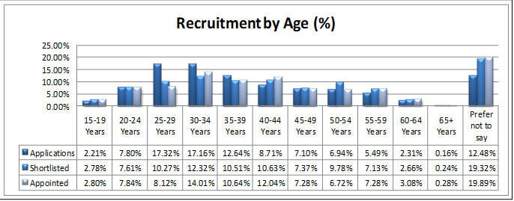

4.7 SEXUAL ORIENTATION

Outcome
We will endeavour to ensure that a person’s sexual orientation, if declared, shall be no obstacle to them as a beneficiary of care.

Rationale
A Trades Union Congress survey of LGB employees in 2000 suggested that 44 per cent had experienced some form of discrimination. Gay or lesbian individuals may be possible targets for hate crime additionally.
Certain sexual health issues may be more prevalent in gay or lesbian populations e.g. gay men are in a higher risk group for HIV. Gay and lesbian people may be less likely to be screened for certain conditions, meaning problems are not picked up as early as they could be. Research done by de Montfort University in 2009 showed that lesbian and bisexual women were up to 10 times less likely to have had a cervical smear test in the preceding 3 years.
These health inequalities are particularly more acute around mental health, where evidence shows:
- Suicidal behaviour is 3 times more prevalent around Lesbian, gay and bisexual when compared to the general population; this rises to 8 times among transgender people
- Self-harm is 8 times more prevalent among LGB people; this rises to 20 times among transgender people

What we’re doing

NHSWI signed up to the NHS Scotland national LGBT+ Pride Badge scheme in June 2021. This incorporated members of staff who wished to do so ( taking part in the scheme was entirely voluntary) signing the LGBT Pride Pledge undertaking to raise awareness around this grouping, following which the Pride Badge with its rainbow logo was given to them to wear. 82 members of staff signed the Pride Pledge after the scheme was publicised.

The Hebridean Pride March has not resumed yet since the pandemic, following the ones that were held in 2018 and 2019.

Workforce
Job Family | Bisexual | % | Declined | % | Dont Know | % | Gay | % | Gay Lesbian | % | Heterosexual | % | Lesbian | % | Other | %
Administrative Services | 0 | 0.00% | 15 | 1.41% | 46 | 4.33% | 0 | 0.00% | <5 | * | 133 | 12.52% | 0 | 0.00% | 0 | 0.00%
Allied Health Profession | <5 | * | 9 | 0.85% | 9 | 0.85% | <5 | * | 0 | 0.00% | 72 | 6.78% | 0 | 0.00% | 0 | 0.00%
Dental Support | 0 | 0.00% | 5 | 0.47% | <5 | * | 0 | 0.00% | 0 | 0.00% | 41 | 3.86% | 0 | 0.00% | 0 | 0.00%
Healthcare Sciences | 0 | 0.00% | <5 | * | <5 | * | 0 | 0.00% | 0 | 0.00% | 20 | 1.88% | 0 | 0.00% | 0 | 0.00%
Medical and Dental | <5 | * | 5 | 0.47% | 6 | 0.56% | 0 | 0.00% | 0 | 0.00% | 24 | 2.26% | 0 | 0.00% | 0 | 0.00%
Medical Support | 0 | 0.00% | 0 | 0.00% | <5 | * | 0 | 0.00% | 0 | 0.00% | <5 | * | 0 | 0.00% | 0 | 0.00%
Nursing and Midwifery | <5 | * | 44 | 4.14% | 91 | 8.57% | <5 | * | 0 | 0.00% | 318 | 29.94% | <5 | * | <5 | *
Other Therapeutic | 0 | 0.00% | 0 | 0.00% | 7 | 0.66% | 0 | 0.00% | 0 | 0.00% | 13 | 1.22% | 0 | 0.00% | 0 | 0.00%
Personal and Social Care | 0 | 0.00% | 0 | 0.00% | <5 | * | 0 | 0.00% | 0 | 0.00% | 15 | 1.41% | 0 | 0.00% | 0 | 0.00%
Senior Managers | 0 | 0.00% | <5 | * | 0 | 0.00% | 0 | 0.00% | 0 | 0.00% | <5 | * | 0 | 0.00% | 0 | 0.00%
Support Services | <5 | * | 8 | 0.75% | 17 | 1.60% | <5 | * | <5 | * | 129 | 12.15% | 0 | 0.00% | <5 | *

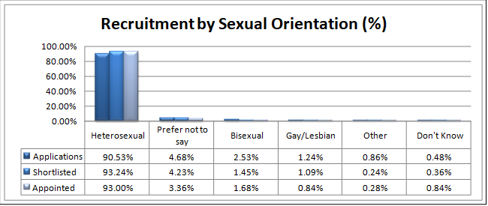

4.8 GENDER REASSIGNMENT

Outcome
We will deal sensitively, & with discretion, any transgender or transsexual patient that comes into our orbit.

Rationale
Surveys have found that rates of mental ill health in this group are higher than the average. Transgender individuals can also face discrimination and harassment and be possible targets for hate crime.
Under the terms of the 2010 Equality Act, the requirement for medical supervision to take place as part of a process of ‘gender reassignment’ has been removed for Gender Reassignment, so someone who simply changes the gender role in which they live without ever going to see a doctor is protected.
What we’re doing
NHS Western Isles has a Policy and Action Plan in place for this, and sensitive awareness and the need for dignity has been stressed at the Equality Act training sessions.

More broadly speaking in the community, this comes under the auspices of the LGBT Working Group set up by DESG (the Western Isles multi-agency Diversity and Equality Steering Group).

4.9 MARRIAGE AND CIVIL PARTNERSHIP

Outcome
NHS Western Isles will give respect and support to all couples who either receive care from the organisation or work for it, in order to promote stable and loving unions.

Rationale
A wide body of research has shown how steadfast and stable couple relationships are vital to the security and welfare of children, and therefore to society as a whole. Domestic violence, as previously mentioned, is particularly corrosive here, but is not the only variable. Difficulties in maintaining a healthy work/life balance can fracture family cohesion unless changes to lifestyle are made.

What we’re doing
Health Visitors and Mental Health staff work effectively with Social Work colleagues to support vulnerable couples and families who are experiencing economic and social difficulties. Where relationships are coming under particular strain, there are referral pathways to the Family Mediation Service counselling support.
Employees who experience particularly stressful family circumstances, such as a child health crisis, can apply through their line manager for Special Leave, within the parameters of the Special Leave Policy.
Specialist interventions such as Family Therapy will be contingent on increased investment in Clinical Psychology and Psychiatry.

4.10 PREGNANCY AND MATERNITY

Outcome
We will give practical and sensitive assistance to expectant and new parents to make this time for them as positive as possible and will uphold the rights and dignity of all women in pregnancy.

Rationale
There are still examples of women losing pay and status, and even their jobs, due to pregnancy. The number of maternity-related employment tribunals has been rising, even as other types of case decline. Over a tenth of sex discrimination claims in GB employment tribunals in 2009-10 concerned pregnancy.
There is limited data which suggests that there may be concentrations of lone mothers in the most deprived neighbourhoods, and that it can be difficult for authorities to engage with those in most need of support.

Most disturbingly, the incidence of physical abuse of women, and particularly domestic violence, increases during pregnancy and early maternity.

There are many common health problems that are associated with pregnancy, such as backache, constipation, sleeplessness and hypertension. There are also health issues such as morning sickness that are specific to pregnancy. This is why health screening and monitoring is such an important aspect of pregnancy care, from the first semester onwards.

What we’ve done

The Parentcraft sessions for expectant parents ceased meeting at the onset of the COVID-19 pandemic. Another challenging consequence of the restrictions was that fathers could not accompany their spouses/partners to Theatre in the case of Caesarean delivery as our theatres are general theatres.
To meet the parent education needs, this was delivered virtually using the Solihull Approach programme.

As NHSWI Maternity Services provide an integrated midwifery service midwives plan, deliver and evaluate care between both hospital and domiciliary settings. Intrinsic to this is an affiliation to GP Practices with close links to the Health Visiting Team. Mothers are supported to make an informed choice as to where they give birth. This aligns with the Best Start ambitions for Maternity Care in Scotland. The BadgerNet database is an agile recording system for storing all the patient data for the whole maternity care journey.
The adaptation to technology instigated by the pandemic can be seen further in that the Antenatal Booking Appointment is now done via NHS Near Me. All of these now include a discussion on Routine Enquiry in relation to domestic abuse.

The Maternity Unit in the Western Isles Hospital purchased their own Language Line InSight Interpreter on Wheels in 2021, after being deeply impressed with the Hospital-wide IOW purchased in 2018. They have a significant number of mothers and spouses whose first language is not English, and the need to provide more effective assistance for foreign language communication was evident. Recent arrivals of Syrian & Ukrainian refugees into the community as part of the Government resettlement programme has been a factor in this.

Following the passing into law of The Forensic Medical Services (Victims of Sexual Offences) (Scotland) Act in 2021 and its receiving Royal Assent on 1 April 2022, this legislation means health boards can now provide Forensic Medical Examinations (FME) after a self-referral, without victims/survivors needing to report to police first. Accordingly, as part of the NHS Sexual Assault Response Co-ordination Service that NHSWI now provides, the Head of the Midwifery Unit undertook training in 2021/22 as a designated Forensic Medical Examiner. This will dramatically improve the quality of the service that victims of sexual assault will receive, of which a streamlined process is a part.
This incorporates a self-referral system with a dedicated NHS telephone number that can be phoned 24 hours a day, 7 days a week.

The former Bosom Buddies local support group for women who are breastfeeding, which offers professional and peer support, moved under the jurisdiction of NHSWI Health Visiting in 2019 and, through this, linked up to the UK-wide Breastfeeding Network. 12 ladies in the community, all mothers with experience of breastfeeding, have now been trained as Breastfeeding Network Peer Supporters. They liaise closely as required with the Health Visitors caseloads, assisted by a part-time BFN Peer Supporter Co-ordinator.

Total Number of Employees on Maternity Leave between 1 st April 2021 - 31st March 2022
Number of Employees | 34
Total Days Lost | 2695
In conclusion, NHS Western Isles is increasingly conscious of the duties incumbent upon us in relation to equity for those we serve, as well as those of equality. This is the acknowledgement fundamentally that the same approach to resolve an inequality problem will not work for everyone, and of the need to discuss solutions with the individual that are tailored to their particular needs and dilemmas in a way that will be distinct from the next person. This is intrinsic to the Person-Centred Care Strategy for NHS Scotland.

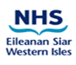5.0
Appendix 1
NHSWI Equal Pay Statement

This statement has been agreed in partnership and will be reviewed on a regular basis by the NHS Eileanan Siar Area Partnership Forum and the Staff Governance Committee. NHS Eileanan Siar is committed to the principles of equality of opportunity in employment and believes that staff should receive equal pay for the same or broadly similar work, or work rated as equivalent and for work of equal value, regardless of their age, disability, ethnicity or race, gender reassignment, marital or civil partnership status, pregnancy, political beliefs, religion or belief, sex or sexual orientation.

NHS Eileanan Siar understands that the right to equal pay between women and men is a legal right under both domestic and European Law. In addition, the Equality Act 2010 (Specific Duties)(Scotland) Regulations require NHS Eileanan Siar to take the following steps:

- Publish gender pay gap information by 30 April 2023; and
- Publish a statement on equal pay between men and women by 30 April 2023, and to include the protected characteristics of race and disability.

It is good practice and reflects the values of NHS Eileanan Siar that pay is awarded fairly and equitably.

National Terms and Conditions

NHS Eileanan Siar employs staff on nationally negotiated and agreed NHS contracts of employment which includes provisions on pay, pay progression and terms and conditions of employment. These include National Health Service Agenda for Change (A4C) Contract and Terms & Conditions of employment, NHS Consultant and General Practice (GP) and General Dental Practice (GDP) contracts of employment and. Some staff are employed on the NHS Scotland Executive contracts of employment (Executive Cohort) which are evaluated using national grading policies with prescribed pay range and terms of conditions of employment. NHS Eileanan Siar recognises that in order to achieve equal pay for employees doing the same or broadly similar work, work rated as equivalent, or work of equal value, it should operate pay systems which are transparent, based on objective criteria and free from unlawful bias.

In line with the General Duty of the Equality Act 2010, our objectives are to:
- Eliminate unfair, unjust or unlawful practices and other discrimination that impact on pay equality;
- Promote equality of opportunity and the principles of equal pay throughout the workforce; and
- Promote good relations between people sharing different protected characteristics in the implementation of equal pay
We will:
- Review this policy, statement and action points with trade unions and professional organisations as appropriate, every 2 years and provide a formal report within 4 years;
- Inform employees as to how pay practices work and how their own pay is determined;
- Provide training and guidance for managers and for those involved in making decisions about pay and benefits and grading decisions to ensure fair and consistent practice;
- Examine our existing and future pay practices for all our employees, including part-time workers, those on fixed term contracts or contracts of unspecified duration, and those on pregnancy, maternity or other authorised leave;
- Undertake regular monitoring of the impact of our practices in line with the requirements of the Equality Act 2010; and
- Consider, and where appropriate, undertake a planned programme of equal pay reviews in line with guidance to be developed in partnership with the workforce and Trade Union representatives.

Responsibility for implementing this policy is held by the Chief Executive with the Human Resources Director having lead responsibility for the delivery of the policy.

Staff Governance Standard

NHS Boards work within a Staff Governance Standard which is underpinned by statute. The Staff Governance Standard sets out what each NHS Scotland employer must achieve in order to continuously improve in relation to the fair and effective management of staff.

The Standard requires all NHS Boards to demonstrate that staff are:
- well informed;
- appropriately trained and developed;
- involved in decisions;
- treated fairly and consistently, with dignity and respect, in an environment where
- diversity is valued; and
- provided with a continuously improving and safe working environment, promoting the health and wellbeing of staff, patients and the wider community.

Delivering equal pay is integrally linked to the aims of the Staff Governance Standard.

If a member of staff wishes to raise a concern at a formal level within NHS Eileanan Siar relating to equal pay, the Grievance Procedure is available for their use.
Appendix 2 NHSI Staff Turnover 2021-22

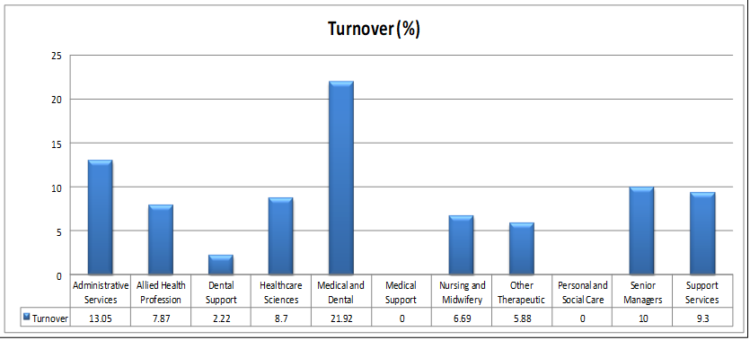

Fairness Assessment Toolkit

This toolkit is designed to be used by those:

- Writing Policies, Procedures & Protocols from start

- Reviewing existing Policies, Procedures, Protocols and services

- Planning new services or redesigning existing ones.

IT IS IMPORTANT THAT AT THE BEGINNING OF THE POLICY DESIGN PROCESS YOU CONSIDER THE REQUIREMENTS OF THIS TOOL. IT IS DESIGNED TO ASK THE QUESTIONS THAT WE SHOULD BE ASKING AT THE START OF PRODUCING OR REVIEWING POLICIES, PROTOCOLS, STRATEGIES AND SERVICES.

Author/Reviewer Name

Name of policy, protocol, procedure, strategy or service
Line Manager responsible for signing Off Policy
Date Started

Date Completed

Key steps for conducting a Fairness Assessment

1. Identify the key aims & outcomes of the policy.

2. Gather information & evidence around protected characteristics & identify the gaps.

3. Assess the impact - consider alternatives & mitigate negative impacts.

4. Involve & consult on impact assessment - internally & externally.

5. Make a decision; develop an Action Plan based on evidence.

6. Sign off; send to Strategic Diversity Lead for sign off.

7. Final Fairness Assessed policy to be published on NHS WI Show website.

8. Monitor & review the final assessment.

Section 1 About your project

Please answer the following questions:

- Is this a new policy?

Yes No

If yes, please explain why it is being done and what the effects of it will be

- Have you checked if there are any other current guidance on this topic in the Health Board?

Yes No

If the answer is No, please stop and check now.

- Please list who is likely to be affected by this project and how they will be affected

Who? | How?

- Please tell us how you are going to involve these people in the project

Section 2 Protected Characteristics

Read the following, as these are about the people or groups of people whose rights are specifically protected under the 2010 Equalities Act. This page gives you information on each of the nine protected characteristics.

- Age

Where this is referred to, it refers to a person belonging to a particular age (e.g. 32 year olds) or range of ages (e.g. 18-30 year olds, 65-80 year olds)

How will these groups be affected?

- Disability

A person has a disability if s/he has a physical or mental impairment which has a substantial and long term adverse effect on that person’s ability to carry out normal day to day activities.

How will this group be affected?

- Gender Reassignment

The process of transitioning from one gender to another.

How will this group be affected?

- Marriage and Civil Partnership
Marriage is defined as a ‘union between a man and a woman’. Same sex couples can have their relationships legally recognised as ‘civil partnerships’. Civil partners must be treated the same as married couples on a wide range of legal matters.

How will this group be affected?

- Pregnancy and Maternity

Pregnancy is the condition of being pregnant or expecting a baby. Maternity refers to the period after the birth, and is linked to maternity leave in the employment context. In the non work context, protection against maternity discrimination is for 26 weeks after giving birth, and this includes treating a woman unfavorably because she is breastfeeding.

How will this group be affected?

- Race

Refers to the protected characteristic of race. It refers to a group of people defined by their race, colour, and nationality (including citizenship) ethnic or national origins.

How will this group be affected?

- Religion and Belief

Religion is the term given to a collection of cultural belief systems based on narratives, traditions and symbols that give meaning to life and instill a moral framework of conduct. Belief includes religious and philosophical beliefs including lack of belief (e.g. atheism). Generally, a belief should affect your life choices for it to be included in the definition.

Does your proposal discriminate or disadvantage any religious or non religious group?

- Sex

A man or a woman. )

Does your proposal discriminate between men and women, if so how and why?

- Sexual Orientation

Whether a person’s sexual attraction is towards their own sex, the opposite sex or to both sexes.

How will this group be affected?

- Negative Findings

If you have found negatives in the above assessments, how do you intend to deal with these, and why?

Section 3 Human Rights

It is unlawful for a public authority to act in a way which is incompatible with a European Convention of human Rights requirements. There are 15 protected rights which public authorities must ensure that they comply with in their policies, services and practices. Those listed below are the ones which can directly be affected by Healthcare provision.

- The right to life – protects your life, by law. The state is required to investigate suspicious deaths and deaths in custody.

Does your proposal affect this right?

- The prohibition of torture and inhuman treatment – you should never be tortured or treated in an inhuman or degrading way, no matter what the situation.

Does your proposal affect this right?

- The right to liberty and freedom – you have the right to be free and the state can only imprison you with very good reason – for example, if you are convicted of a crime.

Does your proposal affect this right?

- The right to a fair trial and no punishment without law – you are innocent until proven guilty. If accused of a crime, you have the right to hear the evidence against you, in a court of law.

Does this proposal affect this right?

- Respect for privacy and family life and the right to marry - protects against unnecessary surveillance or intrusion into your life. You have the right to marry and raise a family.

Does this proposal affect this right?

- Freedom of thought, religion and belief – you can believe what you like and practice your religion or beliefs, so long as this does not harm others.

Does your proposal affect this right?

- No discrimination – everyone’s rights are equal. You should not be treated unfairly – because, for example, of your gender, race, sexuality, religion or age.

Does your proposal affect this right?

Equality Leads Use

Received for review:

Checked by:

Owner of Fairness Assessment:

Comments and recommendations:

Signed: ……………………………..……… Date: ………………………..………
By Strategic Diversity Lead

